GAM Design Findings - Libya
75% of Libya projects (51/68) approved in the 2019 HPC completed the Gender with Age Marker for project design. GAM information summarized here demonstrates considerable attention to gender- and age-related issues in the project design phase.
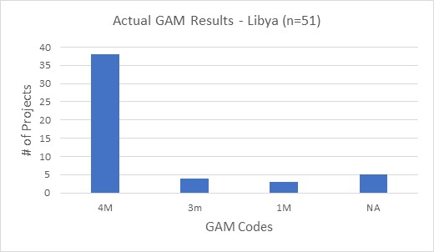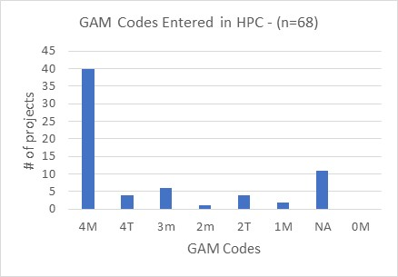
Over 90% of Libya projects address gender differences (Code 3) throughout their program, and most also mainstream age in their design (Code 4.) Five projects indicate that they have no contact with or influence on services for affected people (Code N/A), though this could be debated with respect to humanitarian coordination projects.
The GAM asks users to consider four program elements in project design: analysis, activities, participation and benefits. In ALL of these areas, at least 83% of projects show intention to address gender differences, and in most cases gender and age differences, in their projects.
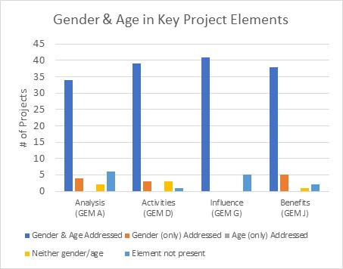
Under analysis, a third of projects (33%) indicate a focus on “women, girls, boys, and men;” 9% are primarily concerned with girls and boys, and 9% say that their analysis is primarily concerned with women. 15% of projects indicate that their analysis is concerned with people of diverse gender orientation/identity, but there is likely confusion about the definition as this gender group is not mentioned in any of the narrative analyses.
STILL DRAFT
One third of projects (32%) demonstrate clear analysis of effects of gender and/or age inequality in Libya. Organizations working with children appear particularly strong in this respect. A smaller group of projects (28%) have a very limited concept of analysis, expressing an intention to address inequality as opposed to an analysis of it, or citing disaggregated statistics often unrelated to their sector or activities. Many projects focus their analysis exclusively on gender-based violence, or on the situation of migrants. Twenty projects (approx. 40%) have no gender analysis.
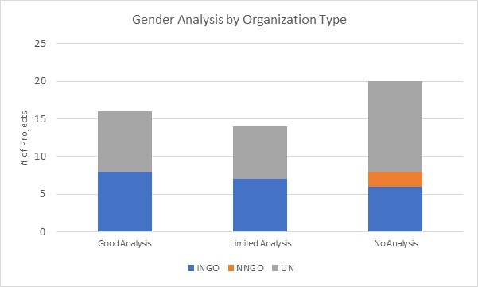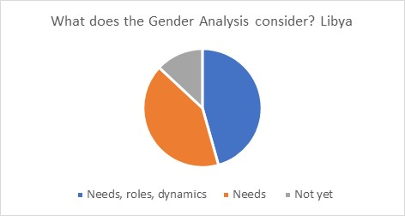

Support is needed to help project holders understand how and gender and age analysis can inform the activities to be delivered, how different groups can be engaged, or how results will be measured; and at sector level to ensure all partners understand the implications of marginalization for their work.
43% of projects plan to adapt or tailor activities on the basis of gendered needs, roles and dynamics, and 54% tailor activities based on different needs. There are no projects that constitute “targeted action” (Code T) to reduce gender barriers or discrimination, which is not unusual in emergencies.
How affected people participate differs widely among projects and shows meaningful response. While 30% say affected people will be involved in all aspects of project management, most are more plausible. 17% of projects involve beneficiaries in three stages – assessment, design and delivery; 11% of projects say people are not involved. The remaining 40% of projects appear to realistically select 1-2 aspects of project management where affected people will be involved.
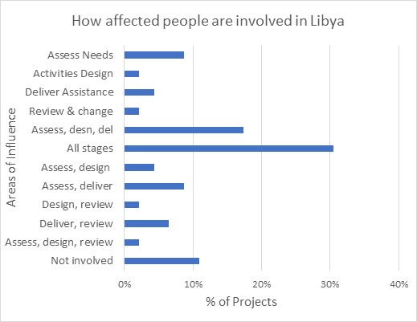
Libya’s high GAM completion rate is due to the enthusiasm and commitment of OCHA humanitarian staff reaching out for support and guidance on the GAM; there were no “trained” GAM resource people or gender advisors involved in-country. It is also notable that there were very few transcription errors when entering codes into HPC. There may still be a misperception that a “targeted action” (T) is somehow better than a project that mainstreams gender (M) as six projects changed their code from (M) to (T) when entering it in HPC tools; only two projects “upgraded” their code from 3 to 4.
In addition to highlighting overall strong desire to address specific needs of different groups in Libya, the GAM also identifies areas and agencies where programming can be more responsive to gender- and age-related exclusion. There may be a need to support some clusters and organizations in developing a socio-economic (gender) context analysis and understanding its relevance to how assistance is designed and delivered, but it is also clear that there is strong capacity for this among several actors in-country.
Users highlight that the GAM has drawn their attention to gender- and age-related concerns that might otherwise have been missed. Use of the IASC Gender with Age Marker by humanitarian actors in Libya shows a shift toward delivering aid at new and higher standards. It is hoped that the support required for its ongoing use in project and program monitoring will be provided.

