Design Results – Bangladesh

Overview

It appears that ALL 149 HPC approved projects for Bangladesh completed the IASC Gender with Age Marker. There are 113/149 approved projects in the GAM database; an additional 36 HPC projects appear to have a valid GAM Reference number - suggesting 100% of Bangladesh project may have applied the GAM. Unfortunately, it appears these 36 users likely failed to press “submit” on completion, as these records are not found in the GAM database. Data is reviewed here for the 113 (76%) Bangladesh projects with completed GAM forms.

Compared to other countries, the GAM completion rate for Bangladesh is high, and use by UN agencies particularly encouraging.
Sample GAM Completion Rates
 | South Sudan | Libya | Ukraine | Bangladesh | Palestine | Somalia | Haiti
HPC Projects  Approved | 396 | 68 | 97 | 149 | 200 | 386 | 89
% with GAM | 19% | 75% | 76% | 76% | 79% | 25% | 19%

In this first year of use, it is important to continue to raise awareness of the purpose of the GAM.
The IASC Gender with Age Marker was designed in response to requests from the field for a tool that would help them understand HOW to do better gender equality programming. People knew they weren’t getting it right, but there was little practical advice on HOW projects could be improved.
The GAM offers 12 programming actions to improve attention to gender and age in projects and programs.
It is the process of discussing and answering the GAM questions about these programming actions that creates better projects - not the specific results that are achieved. Ideally the GAM is used as a team planning or monitoring exercise.
Bangladesh GAM information summarized here demonstrates considerable attention to gender- and age-related issues in the project design phase, among those project holders using the tool.

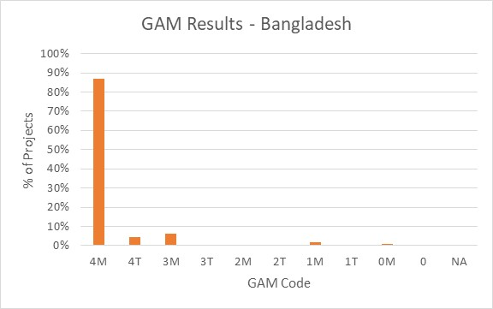
Of the 113 projects applying the GAM, 91% (103 projects) plan to respond to both gender and age differences (Code 4), and a further seven address gender inequalities throughout their program. Five projects are targeted actions (“T”) with a specific purpose to reduce inequality. There are only three projects that do not mainstream gender. No projects indicate that gender differences are not applicable (NA - they have no contact with or influence on services for affected people.)
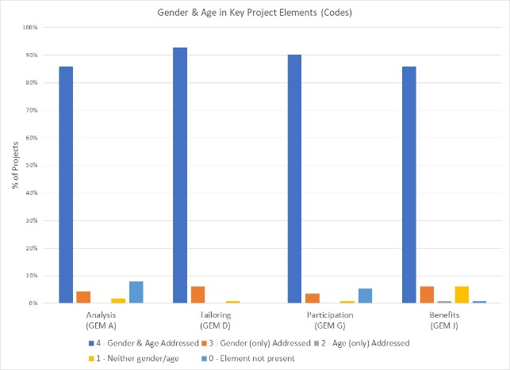

The GAM asks users to consider four program elements in project design: analysis, activities, participation and benefits.
In ALL of these areas, at least 86% of projects show intention to address gender and age differences in their projects.

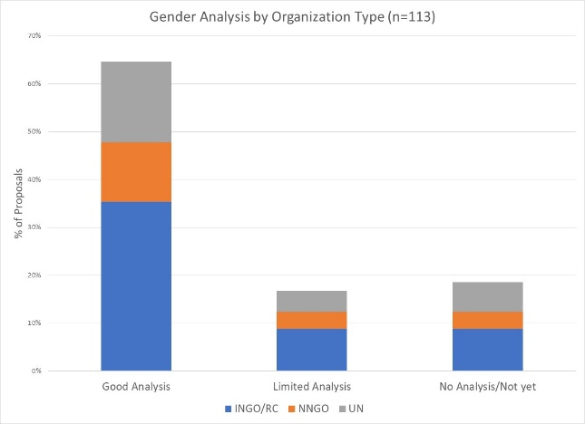
73/113 of Bangladesh projects with GAM (65%) demonstrate a good analysis of gender and/or age inequality in Bangladesh. An additional 17% (19 projects) have a limited concept of analysis, expressing an intention to address inequality as opposed to an analysis of it, or citing disaggregated statistics often unrelated to their sector or activities. Several projects focus their analysis almost exclusively on gender-based violence. Twenty-one projects (19%) have no gender analysis. These projects may need support to understand how the marginalization of certain groups will impact on delivery of their services.

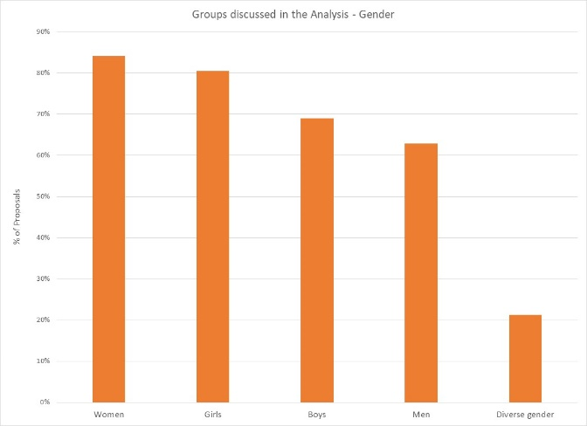
In their analysis, 40% of projects say they consider women and girls and boys and men. An additional 19 projects also include people of diverse gender sexual orientation/ gender identity in their analysis. Overall, women and girls are a focus of analysis in 95% and 91% of projects respectively, while 69% and 63% specifically include boys and men. 24 projects (21%, including those above) indicate that their analysis is concerned with minority gender/sexual orientation groups, but there may be confusion about the definition as this gender group is only occasionally mentioned in narrative analysis.
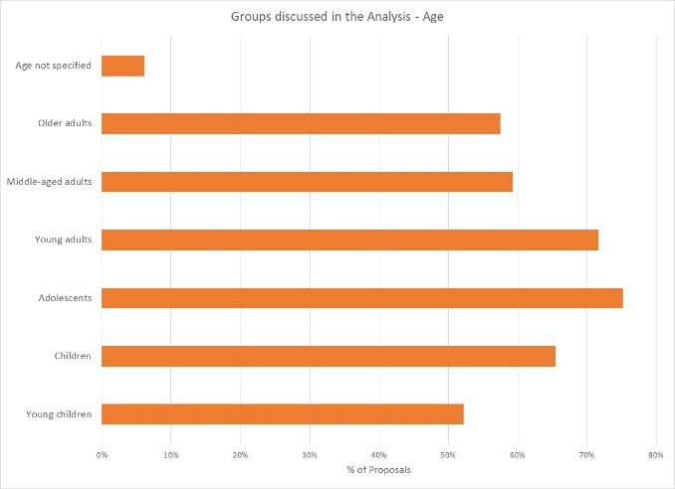
One third of projects indicate their analysis includes all age groups; the majority are more selective, specifying only some of these groups. Adolescents and young adults are the most frequent focus of analysis, in 75% and 72% of projects respectively. Only 58% of projects specifically consider the situation of older adults, and 52% for young children. Seven projects do not specify age groups in their analysis.

The gender analysis narratives show strong evidence of shared gender analysis among organizations and clusters; this will undoubtedly lead to more coherent and responsive projects. Support is needed to ensure all project holders understand how and gender and age analysis can inform the activities to be delivered, how different groups can be engaged, or how results will be measured. Cluster coordinators can be involved to ensure partners share a common analysis of who is at risk and why, and that they understand the implications of this for their project activities.
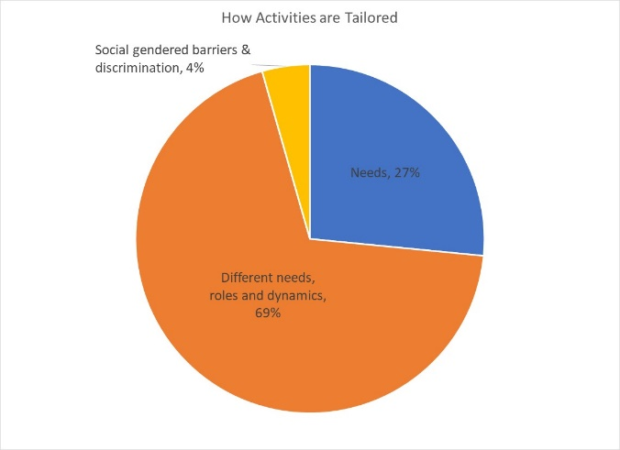
69% of projects plan to adapt or tailor their activities based on different gender-related needs, roles and dynamics, while 27% tailor activities based on the different needs. There are five projects that constitute “targeted actions” (Code T) to reduce gender barriers or discrimination; these are expected to be a small proportion of projects in humanitarian settings.

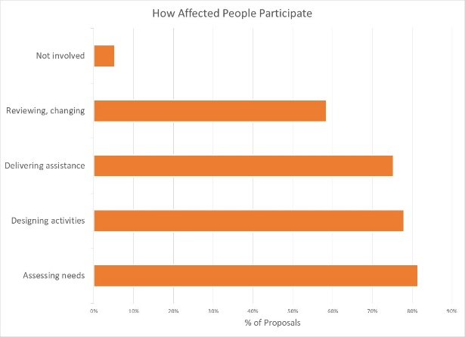
How affected people participate differs widely among projects and shows meaningful response. While 51% of projects say affected people will be involved in all aspects of project management, most are more realistic. The largest proportion of projects involve beneficiaries in assessing needs, followed by designing activities and delivering assistance. Only 58% of projects have affected people involved project review and revision. There are six projects where affected people will not be involved in any of these activities.

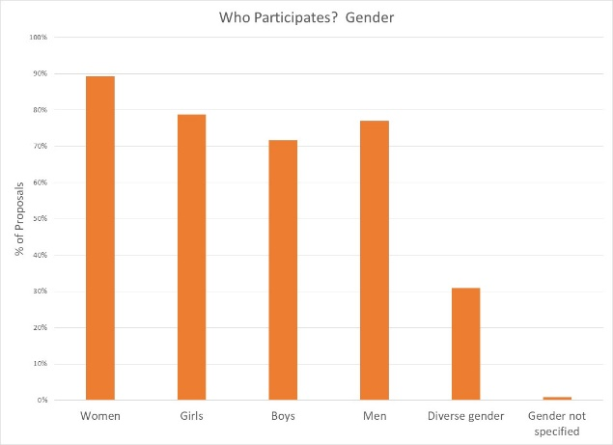

Women are the largest group of intended participants, with 89% of projects planning for them to be involved in at least one aspect of project management. Engagement of men, girls and boys is only slightly lower. 31% of projects indicate people of diverse gender/sexual orientation will be involved.

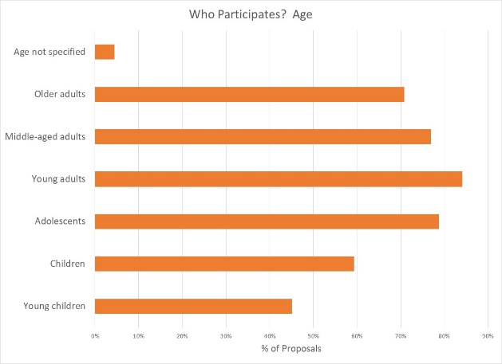

Participation by age groups reflects the concerns seen in the context analysis, with young adults and adolescents most engaged. 71% of projects intend to involve older adults in aspects of project management; children and young children appear to be participating in (logically) fewer projects.

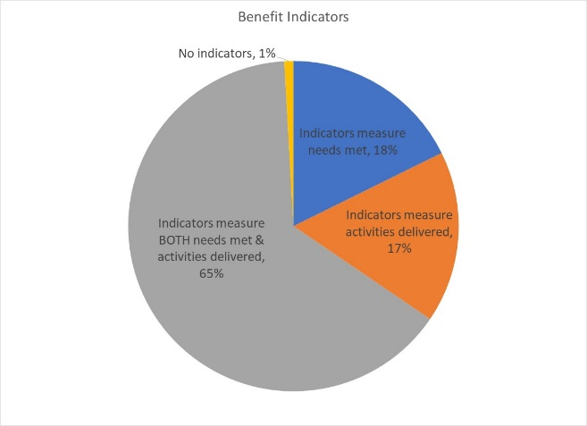
Reporting relative benefits
65% of projects say they will be able to provide disaggregated information on both the activities delivered, and the needs met. 18% of projects plan to report on needs met, and 17% on activities delivered, for different gender and age groups. One project reports no indicators yet.

Summary
It will be important to ensure that the remaining HPC approved projects lacking GAM results apply the GAM before beginning implementation. The GAM can be applied several times, as project holders decide to review and adjust their programs. Users report that the GAM draws their attention to gender- and age-related concerns that might otherwise be missed.
A total of 154 GAM forms were completed for Bangladesh, including 41 for projects that were not accepted in the HPC. There are 149 accepted projects in the HPC; the IASC Gender with Age Marker was completed for 113 (76%) of these. 36 additional projects may have applied the GAM, but the information was not actually submitted and cannot be analyzed.
There were only seven “transcription errors” when copying GAM codes into the HPC. These suggest there may still be a misperception that a “targeted action” (T) is somehow better than a project that mainstreams gender (M). Six projects changed their code from 4(M) to 4(T) when entering it into HPC tools; only one project ‘upgraded’ their code from 0 to 4(M). The analysis in this report is based on the correct GAM scores from the GAM data base.
It is commendable that the Gender with Age Marker was applied to such a high proportion of Banglades projects, given the lack of formal direction and few trained GAM resource people in-country.
In addition to highlighting overall desire to address the needs of specific groups of concern – particularly women and adolescents/young adults in Bangladesh -- the GAM also identifies areas and agencies where programming can be more responsive to gender- and age-related exclusion. There may be a need to support some organizations in strengthening socio-economic (gender) context analysis and understanding its relevance to how assistance is designed and delivered. It is also clear that there is strong capacity for this among several actors in-country.
Use of the IASC Gender with Age Marker by humanitarian actors in Bangladesh shows a shift toward delivering aid at new and higher standards. It is intended that ALL projects accepted in the HPC will apply the IASC Gender with Age Marker prior to starting implementation, and hoped that the support required for its ongoing use in project and program monitoring will be provided.
Follow-up reports will be provided as more Bangladesh actors complete their GAM forms.

