Design Results – Haiti

METHODOLOGY

Steps to compare and analyze HPC and GAM databases.

Step 1: Sort the HPC data by status “accepted”. There are 64 for Haiti.
Pull the correct GAM Code from GAM database into the HPC worksheet, using VLOOKUP on the GAM reference number. This shows projects with valid GAM reference number occurring in the HPC. (HPC Accepted Project column H)
There are 16 projects in the HPC a with valid GAM reference number. An additional 4 appear to have a GAM Reference number but do not appear in the GAM database (probably failed to press submit.)
Highlight duplicate GAMs in the HPC worksheet using conditional formatting. Two organizations have entered the same GAM reference number for TWO accepted projects: Habitat for Humanity and IOM. CARE also submitted one GAM for two projects, but the reference number is not found in GAM.
So there are actually 14 completed GAM forms for Haiti, according to the HPC.
Step 2: Haiti GAMTool Datafile: There are 20 GAM forms in the GAM database for Haiti.
Pull the HPC project ID number into the GAM database, using VLOOKUP on the GAM Reference Numbers. (Column B)
There are 14 GAMs with a valid HPC Project ID in the GAM database.
An additional 6 GAMs were completed, but these are not for projects found in the HPC.
Step 3: Double check - Pull the HPC line number for each project into GAM data, by matching the HPC Project ID from GAM database, with the line number where it occurs in the HPC. (=MATCH, Column C.) This confirms that projects with duplicate GAM forms are not found in the GAM database.

Overview

There are 64 accepted projects in the Haiti HPC.
14/64 (22%) of Haiti projects approved in the 2019 HPC have a completed Gender with Age Marker form. Two organizations used the same GAM form for two projects (Habitat for Humanity and IOM). Four additional HPC accepted projects appear to have a valid GAM Reference number, but users likely failed to press “submit” on completion, as these forms are not found in the GAM database. 60 projects did not apply the GAM.
Compared to other countries, the GAM completion rate for Haiti is low, but not surprising in the first year of use. The lack of use by UN Agencies is somewhat disappointing: only two UNFPA and one IOM project applied the GAM. HPC accepted Projects for FAO, UNICEF, WFP, WHO, UNDP, OCHA and UNESCO did not apply the GAM.
Sample GAM Completion Rates (at Feb 1, 2019)
 | South Sudan | Libya | Ukraine | Haiti | Palestine | Somalia | Nigeria
HPC Projects  Approved | 396 | 68 | 97 | 64 | 200 | 386 | 169
% with GAM | 19% | 75% | 76% | 22% | 79% | 25% | 26%

In this first year of use, it is important to continue to raise awareness of the purpose of the GAM.
The IASC Gender with Age Marker was designed in response to requests from the field, for a tool that would help them understand HOW to do better gender equality programming. People knew they weren’t getting it right, but there was little practical advice on HOW projects could be improved.
The GAM offers 12 programming actions to improve attention to gender and age in projects and programs.
It is the process of discussing and answering the GAM questions about these programming actions that creates better projects - not the specific results that are achieved. Ideally the GAM is used as a team planning or monitoring exercise.

Haiti GAM information summarized here demonstrates considerable attention to gender- and age-related issues in the project design phase, among those project holders using the tool.

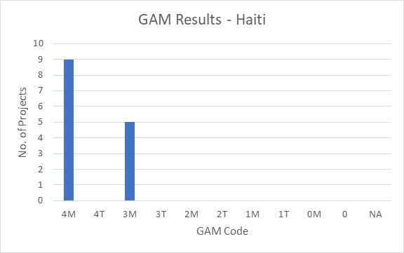
Of the 14 projects applying the GAM, 64% (9 projects) plan to respond to both gender and age differences (Code 4) throughout their program, and an additional 5 project intends to address gender (Code 3). All projects mainstream attention to gender equality. No projects indicate that gender differences are not applicable (Code N/A.)

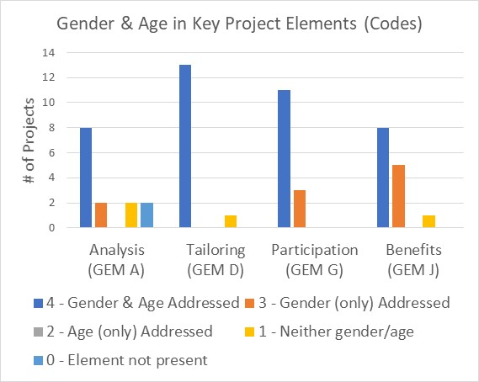

The GAM asks users to consider four program elements in project design: analysis, activities, participation and benefits.
In ALL of these areas, at least 8/14 projects (57%) show intention to address both gender and age differences

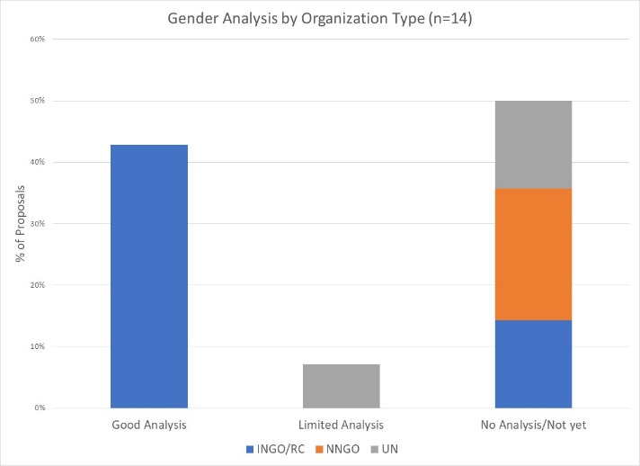

Almost half of Haiti projects with GAM (43%) demonstrate a good analysis of gender and/or age inequality in Haiti. Interestingly, these are all INGOs. One project has a limited concept of analysis, focusing exclusively on gender-based violence. Seven projects (50%) do not have a gender analysis.

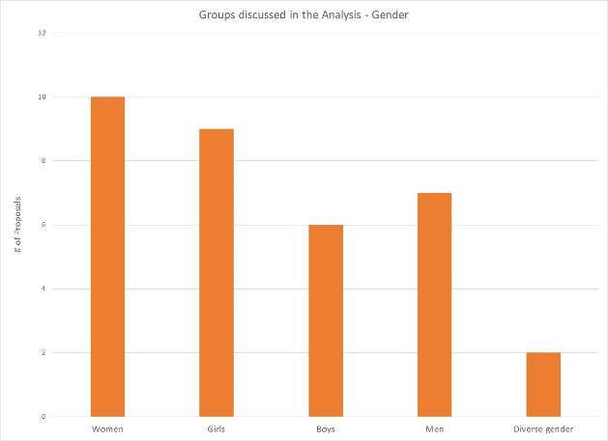
Four projects (29%) say they consider women, girls, boys and men in their analysis. Overall, girls and women are a focus of analysis in 9/14 and 10/14 projects respectively, while 6 projects specifically address boys, and 7 include men. Two projects indicate that their analysis is concerned with people of diverse gender sexual orientation/ gender identity, but there may be confusion about the definition as this gender group is not mentioned in any of the narrative analyses.

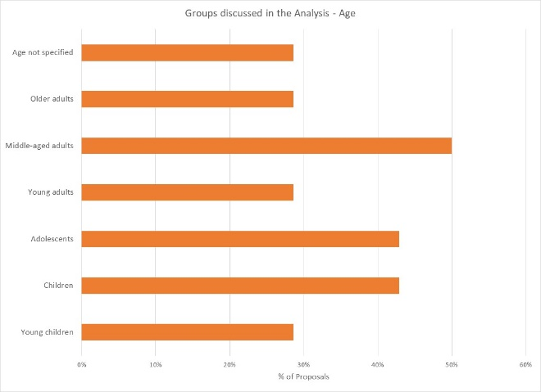
Three projects indicate their analysis includes all age groups; the majority are more selective. Middle-aged adults are a focus of analysis in half of projects; adolescents and children are included in 6/14 projects. A smaller proportion of projects specifically analyze the situation of older adults, young adults, and children. Four projects do not specify age groups in their analysis.

Support is needed to help project holders understand how and gender and age analysis can inform the activities to be delivered, how different groups can be engaged, or how results will be measured. Cluster coordinators can be involved to ensure partners share a common analysis of who is at risk and why, and that they understand the implications of this for their project activities.
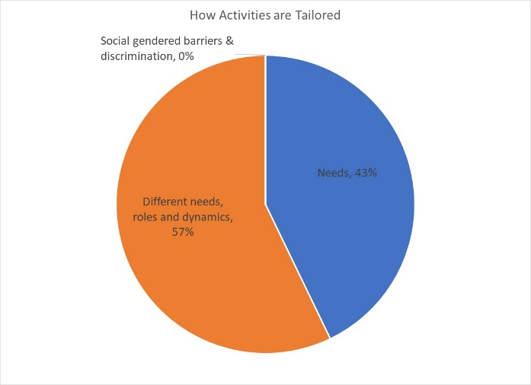

57% (8/14) of projects plan to adapt or tailor their activities based on different gender-related needs, roles and dynamics, while 43% (6/14) tailor activities based on the different needs. There are no projects considered “targeted action” (Code T) to reduce gender barriers or discrimination; there are usually very few such projects in humanitarian settings.

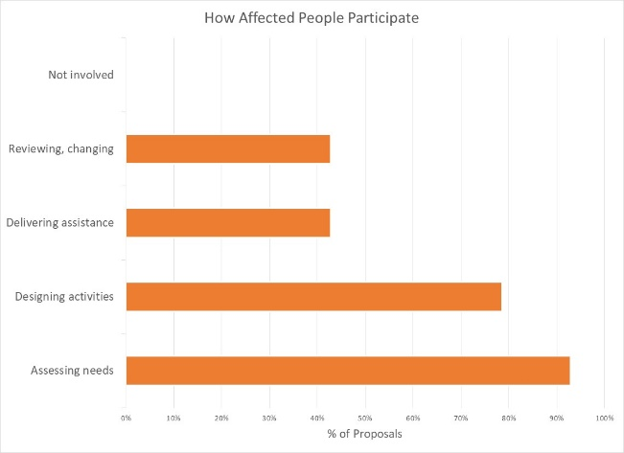
How affected people participate differs widely among projects and shows meaningful response. While four projects say affected people will be involved in all aspects of project management, most are more realistic. The largest proportion of projects involve beneficiaries in assessing needs and/or designing activities. Less than half of projects have beneficiaries involved in delivering the assistance, or in project review and revision. There are no projects where affected people will not be involved in any of these activities.

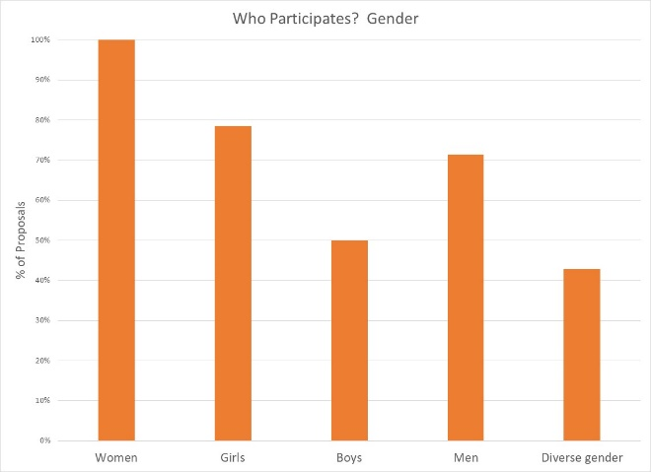

All projects intend to ensure women are involved in at least one aspect of project management; engagement of other gender groups is more varied. Six projects expect the participation people of diverse gender/sexual orientation.

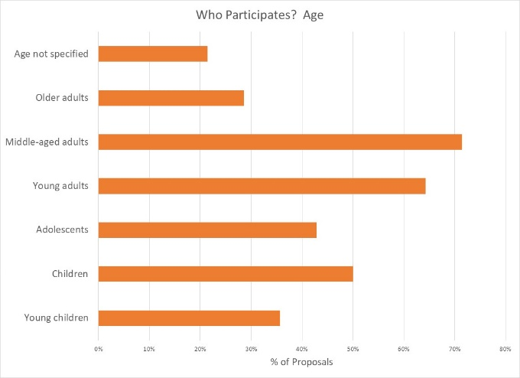
Participation by age groups seems similarly well-thought. It is likely that most people influence project management will be middle-aged and young adults; it is encouraging to see several projects intending for children and adolescents to have an active role. Lowest levels of participation are by older adults and young children; while the latter is probably realistic, one hopes more might be done to engage with the elderly.

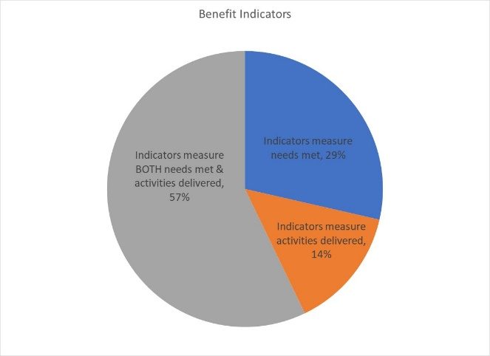
Reporting relative benefits
Eight projects (57%) say they will be able to provide disaggregated information on both the activities delivered, and the needs met. Smaller numbers of projects (four and two respectively) plan to report on either needs met or activities delivered, for different gender and age groups.

Summary
It will be important to ensure that HPC approved projects apply the GAM before beginning implementation. The GAM can be applied several times, as project holders decide to review and make adjustments to their programs. Users report that the GAM has drawn their attention to gender- and age-related concerns that might otherwise have been missed.
A total of 20 GAM forms were completed for Haiti, including six for projects that were not accepted in the HPC. There are 64 accepted projects in the HPC; the IASC Gender with Age Marker was completed for 14 (22%) of these. Three additional accepted HPC projects cite a GAM reference (including one duplicate) but it appears that these users failed to actually “submit” the GAM form.
There was one “transcription error” when copying GAM codes into the HPC. One project correctly coded 3M (gender mainstreamed) entered its code as 1M (gender-blind) in the HPC.
It is commendable that the Gender with Age Marker was applied to these projects in Haiti, given the lack of formal direction from Agencies and few trained GAM resource people involved in-country. There was considerable support from OCHA Geneva.
In addition to highlighting overall strong desire to address specific needs of different groups in Haiti, the GAM also identifies areas and agencies where programming can be more responsive to gender- and age-related exclusion. There may be a need to support some clusters and organizations in developing a socio-economic (gender) context analysis and understanding its relevance to how assistance is designed and delivered, but it is also clear that there is strong capacity for this among several actors in-country.
Use of the IASC Gender with Age Marker by humanitarian actors in Haiti shows a shift toward delivering aid at new and higher standards. It is hoped that the support required for its ongoing use in project and program monitoring will be provided.
It is intended that ALL projects accepted in the HPC will apply the IASC Gender with Age Marker prior to starting implementation. Follow-up reports will be provided as more Haiti actors complete their GAM forms. Further details (e.g. GAM analysis at agency or cluster level) can be provided on request.

