Design Results – Libya

Overview

75% (51/68) of Libya projects approved in the 2019 HPC completed the Gender with Age Marker, among the highest rates for countries using the GAM. Fourteen additional HPC accepted projects appear to have a valid GAM Reference number, but users likely failed to press “submit” on completion, as these forms are not found in the GAM database. Only three projects failed to apply the GAM.
Sample GAM Completion Rates (at Feb 1, 2019)
 | South Sudan | Iraq | Ukraine | Libya | Palestine | Somalia | Nigeria
HPC Projects  Approved | 124 | 193 | 97 | 68 | 200 | 386 | 169
% with GAM | 19% | 68% | 76% | 75% | 79% | 25% | 26%

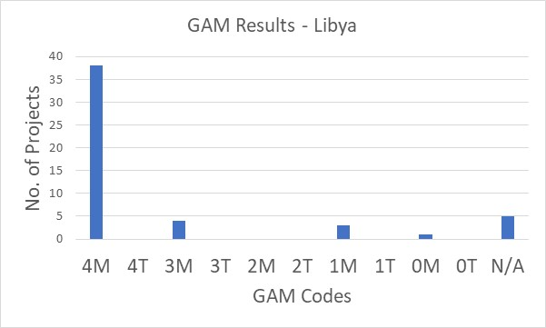
Libya GAM information summarized here demonstrates considerable attention to gender- and age-related issues in the project design phase, by most project holders using the tool.
Of the 51 projects applying the GAM, 75% (38 projects) plan to respond to both gender and age differences (Code 4) throughout their program, and an additional four projects intend to address gender. There are only four projects that do not mainstream gender. Five projects indicate that they have no contact with or influence on services for affected people (Code N/A), though this could be debated with respect to humanitarian coordination projects, and especially for “Cash and Markets.”

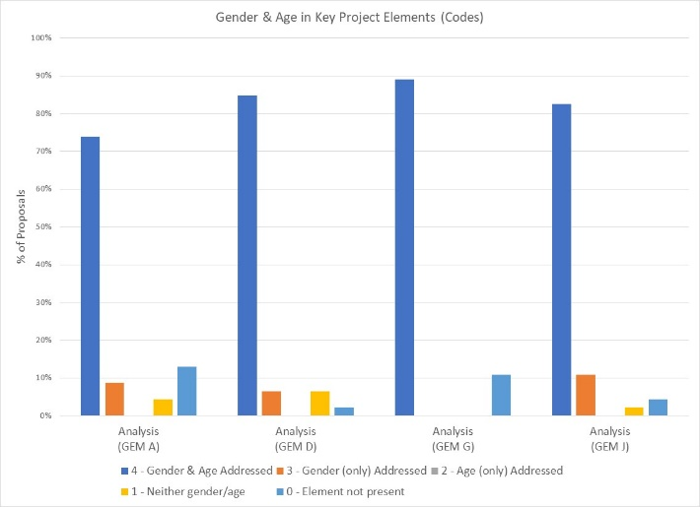

The GAM asks users to consider four program elements in project design: analysis, activities, participation and benefits.
In ALL of these areas, at least of 72% projects show intention to address gender and age differences in their projects.

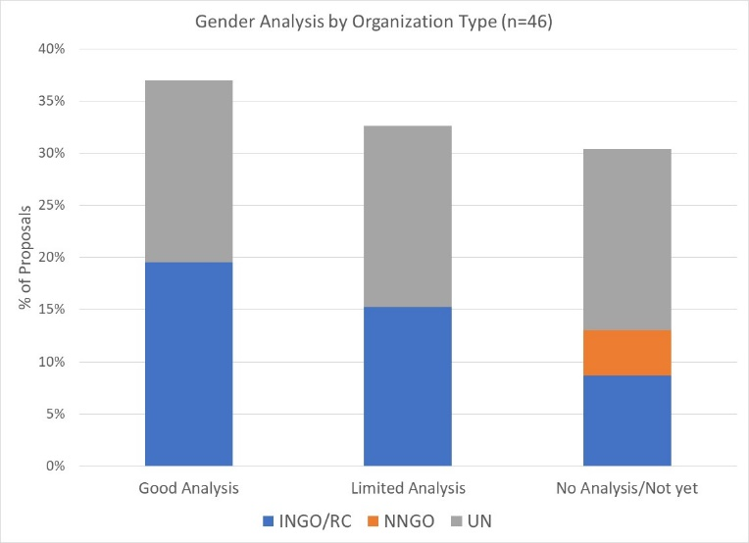
More than one third of projects (37%) demonstrate a good analysis of gender and/or age inequality in Libya. An additional third (33%) have a limited concept of analysis, expressing an intention to address inequality as opposed to an analysis of it, or citing disaggregated statistics often unrelated to their sector or activities. Several projects focus their analysis exclusively on gender-based violence. Fourteen projects (approx. 30%) have no gender analysis.

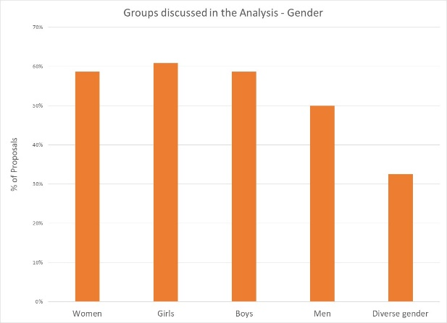
In their analysis, 33% of projects say they consider women, girls, boys and men. Overall, 60% of projects focus on women, girls and/or boys, and 50% also specifically include men. 33% of projects (15) indicate that their analysis is concerned with people of diverse gender sexual orientation/ gender identity, but there is likely confusion about the definition as this gender group is not mentioned in any of the narrative analyses.

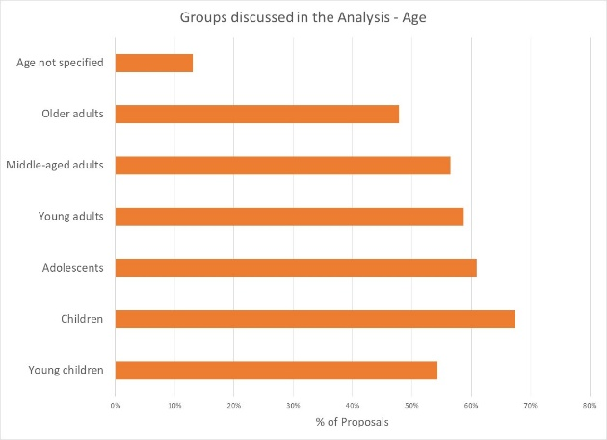

39% of projects indicate their analysis includes all age groups, while the majority are more selective. Only 48% of projects will specifically respond to older adults. Young children and adolescents are addressed by 54% and 61% of projects respectively. Six projects do not specify age groups of concern.

Support is needed to help project holders understand how and gender and age analysis can inform the activities to be delivered, how different groups can be engaged, or how results will be measured. Cluster coordinators can be involved to ensure partners share a common analysis of who is at risk in the crisis and why, and that they understand the implications of this for their project activities.

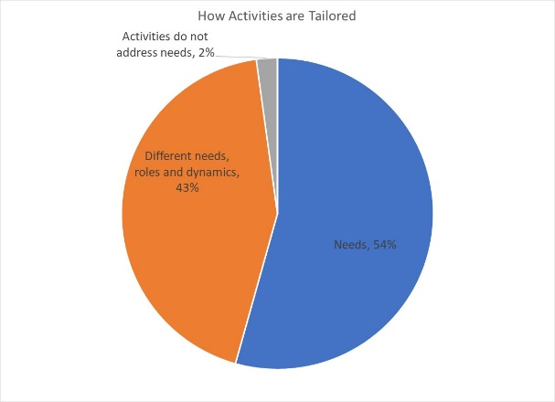

43% of projects plan to adapt or tailor their activities based on different gender-related needs, roles and dynamics, while 54% tailor activities based on different needs. There are no projects that constitute “targeted action” (Code T) to reduce gender barriers or discrimination; this is quite normal in humanitarian settings.

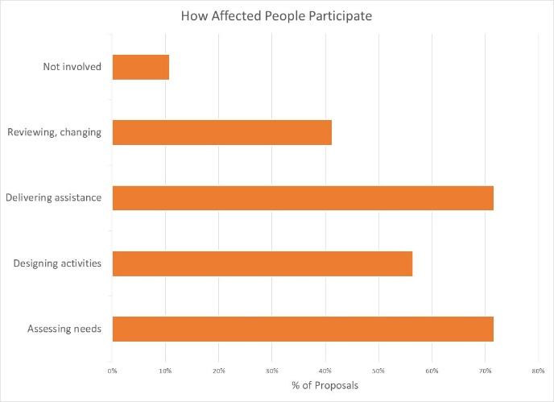
How affected people participate differs widely among projects and shows meaningful response. While 30% say affected people will be involved in all aspects of project management, most are more realistic. 72% of projects involve beneficiaries in assessing needs and/or delivering assistance. Only 57% of projects have beneficiaries involved in designing the activities, and 41% involve affected people in project review and revision. Five projects indicate that affected people are not involved in any of these activities.

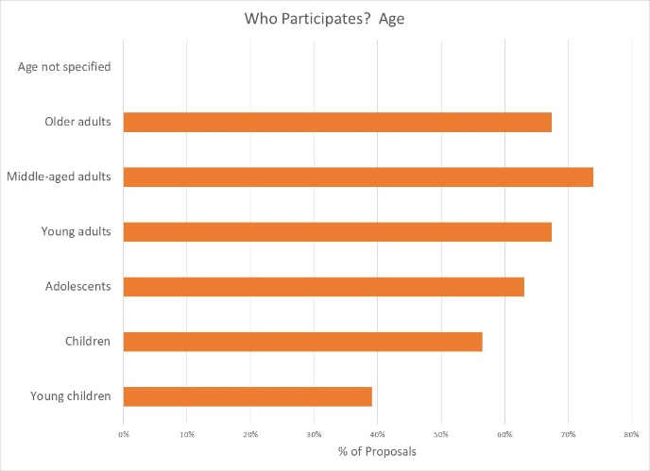

Participation by gender is roughly equal, but age groups are notably different. While it seems unlikely that young children will directly influence project management (39% of projects,) 67% to 74% of projects say that young, middle-aged and older adults will participate. Adolescent participation is slightly lower at 63%.

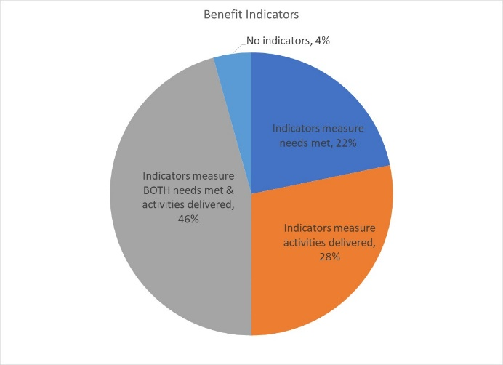
Reporting relative benefits
46% of projects say they will be able to provide disaggregated information on both the activities delivered, and the needs met. Smaller proportions (28% and 22% of projects) plan to report on either activities delivered or needs met, for different gender and age groups. Two projects do not yet have disaggregated indicators.

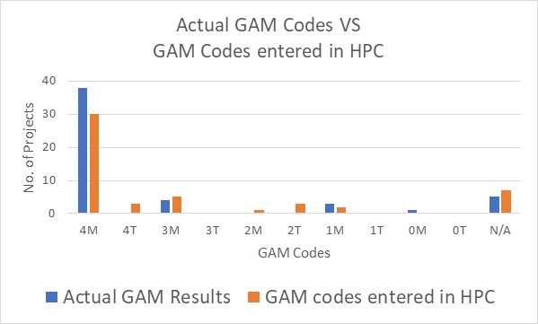
Summary
A total of 64 GAM forms were completed for Libya, including 13 for projects that were not accepted in the HPC. There are 68 accepted projects in the HPC; the IASC Gender with Age Marker was completed for 51 (75%) of these. 65 of the accepted HPC projects cite a GAM code (three do not,) but it appears that 14 users failed to actually “submit” the GAM form.

There a few “transcription errors” when copying GAM codes into the HPC. These show that there may still be a misperception that a “targeted action” (T) is somehow better than a project that mainstreams gender (M). Six projects changed their code from (M) to (T) when entering it in HPC tools; four projects ‘downgraded’ their code from 4 to 2, possibly reflecting that Code 2 was the required score under the old IASC gender marker. Only one project ‘upgraded’ their code from 2 to 3 to 4, although two projects changed codes 0 and 1 to N/A. (Analysis in this report is based on the correct GAM scores in the GAM data base.)

Libya’s high GAM completion rate is due to the enthusiasm and commitment of OCHA humanitarian staff reaching out for support and guidance on the GAM; there were no “trained” GAM resource people or gender advisors involved in-country.
In addition to highlighting overall strong desire to address specific needs of different groups in Libya, the GAM also identifies areas and agencies where programming can be more responsive to gender- and age-related exclusion. There may be a need to support some clusters and organizations in developing a socio-economic (gender) context analysis and understanding its relevance to how assistance is designed and delivered, but it is also clear that there is strong capacity for this among several actors in-country.
Users highlight that the GAM has drawn their attention to gender- and age-related concerns that might otherwise have been missed. Use of the IASC Gender with Age Marker by humanitarian actors in Libya shows a shift toward delivering aid at new and higher standards. It is hoped that the support required for its ongoing use in project and program monitoring will be provided.
It is intended that ALL projects accepted in the HPC will apply the IASC Gender with Age Marker prior to starting implementation. Follow-up reports will be provided as more Libya actors complete their GAM forms.

