

**Design Results – Somalia**

**Overview**

85/352 (24%) Somalia projects accepted in the 2019 HPC have a completed Gender with Age Marker form. 54 additional HPC accepted projects *appear* to have a GAM Reference number so users may have completed the form but failed to press “submit” on completion; these 54 projects do not have a valid GAM on record. There are no projects for which the Gender with Age Marker is not applicable.

A total of 267 accepted Somalia projects have not yet completed the GAM. Compared to other countries, the GAM completion rate for Somalia is LOW, but still quite good for the first year of use.

Sample GAM Completion Rates (March, 2019)



In this first year of use, it is important to continue to raise awareness of the purpose of the GAM.

The IASC Gender with Age Marker was designed *in response to requests from the field*, for a tool that would help them understand HOW to do better gender equality programming.  People knew they weren’t getting it right, but there was little practical advice on HOW projects could be improved.

The GAM offers 12 programming actions to improve attention to gender and age in projects and programs.

It is the process of discussing and answering the GAM questions about these programming actions that creates better projects - not the specific results that are achieved.  Ideally the GAM is used as a team planning or monitoring exercise.

Somalia GAM information summarized here demonstrates considerable attention to gender- and age-related issues in the project design phase, among those project holders using the tool.

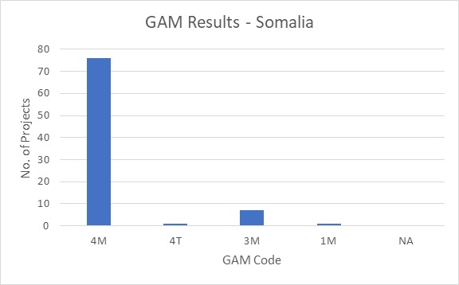Of the 85 projects applying the GAM, 91% (77 projects) plan to respond to both gender and age differences (Code 4) throughout their program, and an additional 7 project intends to address gender (Code 3). There is one project that addresses neither gender or age (Code 1.) One project is a targeted action to specifically to address inequality; there are usually very few such projects in humanitarian settings. No projects indicate that gender differences are not applicable (Code N/A.)

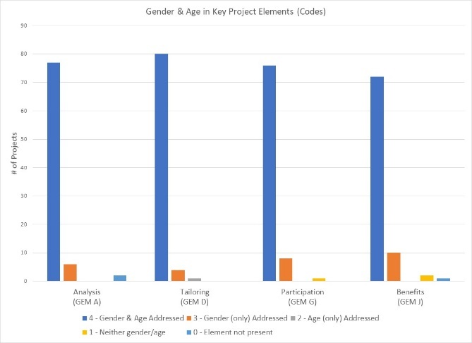

The GAM asks users to consider four program elements in project design: analysis, activities, participation and benefits*.*

In ALL of these areas, at least 72/85 projects (85%) show intention to address both gender and age differences

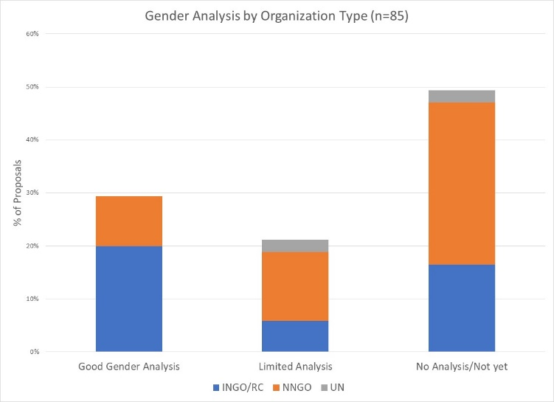

The concept of gender analysis appears quite weak in Somali projects: almost half of projects do not describe and compare the situations of men and women in the context of their project or sector. Most often the analysis narrative describes project intentions regarding gender equality, or simply presents a set of population figures. The absence of analysis suggests that many projects may be unable to systematically address inequalities during implementation.

25 projects demonstrate a reasonably good basic analysis of gender and/or age inequality in Somalia. A further 18 projects have a limited of analysis, often focused exclusively on gender-based violence.

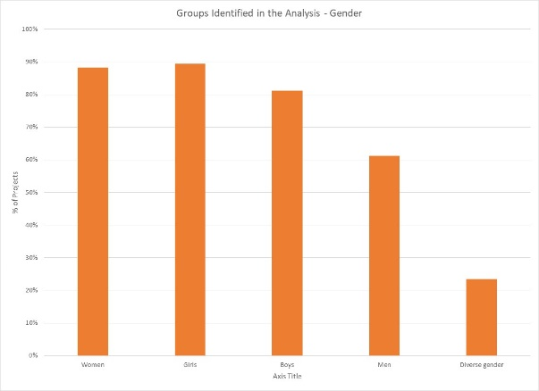36 projects (42%) say they consider women, girls, boys and men in their analysis. Overall, girls and women are a focus of analysis in 89% and 88% of projects respectively; 81% include boys, and 61% include men. Twent projects indicate that their analysis is concerned with people of diverse gender sexual orientation/ gender identity, but there may be confusion about the definition as this gender group is not mentioned in any of the narrative analyses.

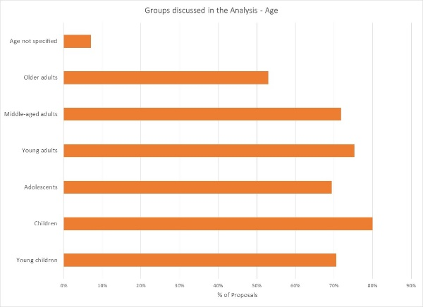

34 projects (40%) indicate their analysis includes all age groups; the majority are more selective. 80% of projects include children as a focus of analysis. Other age groups are included in 69% to 75% of analyses, with the exception that older adults are addressed by only 53% of project analyses. Six projects do not specify age groups in their analysis.

Support is needed to help project holders understand how and gender and age analysis can inform the activities to be delivered, how different groups can be engaged, or how results will be measured. Cluster coordinators can be involved to ensure partners share a common analysis of who is at risk and why, and that they understand the implications of this for their project activities.

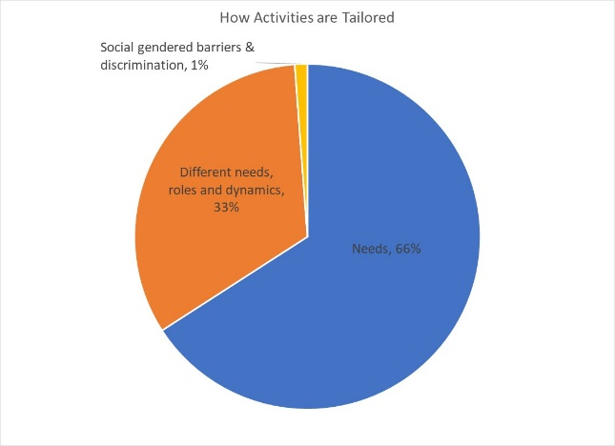

66% of projects (56/85) plan to adapt or tailor their activities based on different gender-related, while 33% (28 projects) plan to tailor activities based on different needs, roles and dynamics. There is one project that is a “targeted action” (Code T) to reduce gender barriers or discrimination; there are usually very few such projects in humanitarian settings.

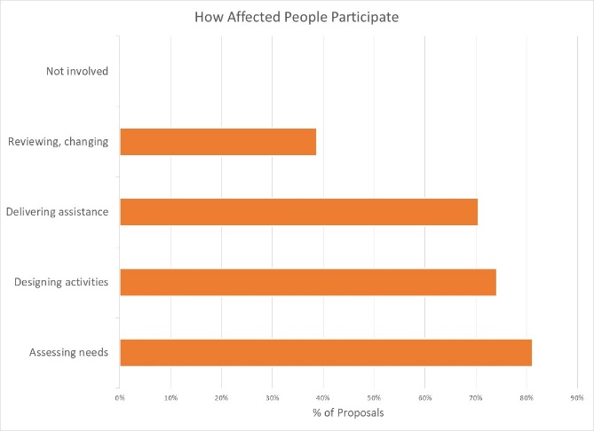How affected people participate differs widely among projects and shows meaningful response. While 33% of projects say affected people will be involved in *all* aspects of project management, most are more realistic. The largest proportion of projects involve beneficiaries inassessing needs, followed by designing activities and delivering assistance. Only 39% of projects (33/85) intend to have beneficiaries involved in project review and revision. There are no projects where affected people will not be involved in any of these activities.

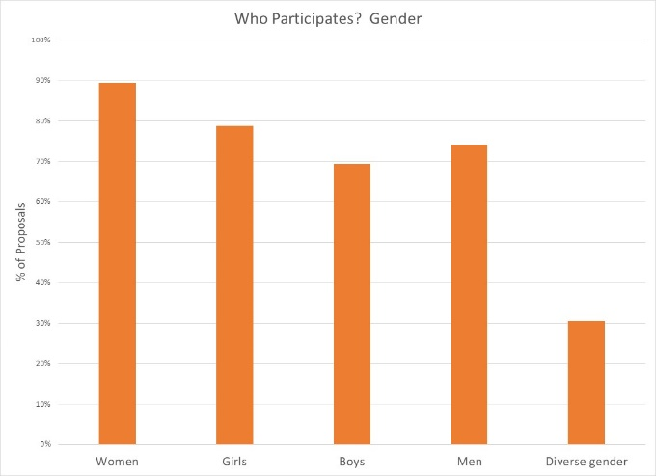

89% of projects intend to ensure women are involved in at least one aspect of project management; engagement of other gender groups is lower, with 59% of projects intending to engage with boys. 26 projects expect the participation people of diverse gender/sexual orientation.

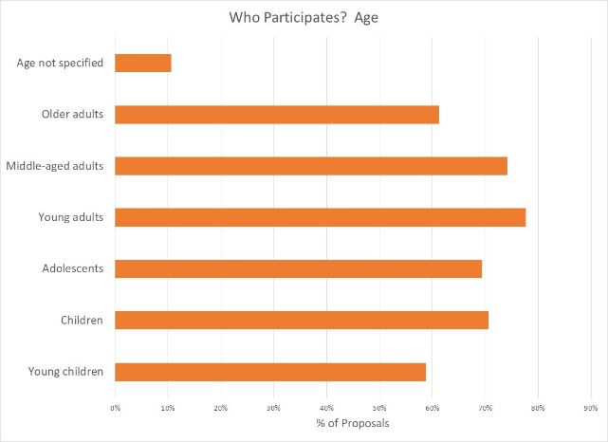

Participation by age groups is similarly varied. It makes sense that most people influencing project management will be young adults and middle-aged adults; it is encouraging to see several projects intending for children and adolescents to have an active role. Lowest levels of participation are by older adults and young children; while the latter is probably realistic, one hopes more might be done to engage with the elderly.

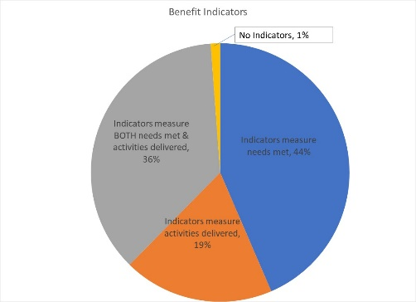Reporting relative benefits

31 projects (36%) say they will be able to provide disaggregated information on both the activities delivered. A larger number (37 projects) plan indicators to report on the different needs met, while 16 projects (19%) intend to report on the activities delivered, for different gender and age groups.

Summary

It is commendable that the Gender with Age Marker was applied to so many projects in Somalia, given the lack of formal direction from Agencies and few trained GAM resource people involved in-country. In addition to highlighting overall strong desire to address specific needs of different groups in Somalia, the GAM also identifies areas and agencies where programming can be more responsive to gender- and age-related exclusion. Ahead of the next HPC season, there is a clear need to support some clusters and organizations in developing a socio-economic (gender) context analysis and understanding its relevance to how assistance is designed and delivered, but it is also clear that there is strong capacity for this among several actors in-country. Given increased demand for ***relevant*** humanitarian programming, support is needed to help project holders understand how and gender and age analysis should inform the activities to be delivered, how different groups can be engaged, and how results can be measured.

A total of 148 GAM forms were completed for Somalia, including 63 for projects that were not accepted in the HPC. There are 352 accepted projects in the HPC; the IASC Gender with Age Marker was completed for 85 (24%) of these. 267 additional accepted HPC projects do not have a completed Gender with Age Marker.

Almost a quarter of Somalia project-holders changed the GAM code received when copying it into the HPC. There were 21 “transcription errors,” indicating a high level of misunderstanding of the purpose of the exercise. ***If the GAM is to have its intended impact on project quality, it must be clear that the code received is in no way tied to project acceptance or funding.*** It is the process of completing the GAM that improves the quality of action; evidence is only required that the process has been completed.

There is clearly a misperception that a “targeted action” (T) is somehow better than a project that mainstreams gender (M). 17 projects changed their code from (M) to (T) when entering it into HPC tools, including three who also changed their numeric code. Whether a project mainstreams gender or is a targeted action to address inequality is determined automatically by the answers selected. Four projects changed only the numeric code.

Use of the IASC Gender with Age Marker by humanitarian actors in Somalia shows a shift toward delivering aid at new and higher standards. Users report that the GAM draws attention to gender- and age-related concerns that might otherwise have been missed.

It is important that ALL projects accepted in the HPC will apply the IASC Gender with Age Marker prior to starting implementation. The GAM can be applied several times, as project holders decide to review and adjust their programs. It is hoped that the support required for its ongoing use in project and program monitoring will be provided. Follow-up reports will be provided as more Somalia actors complete their GAM forms. Further details (e.g. GAM analysis at agency or cluster level) can be provided on request.

**METHODOLOGY**

(Steps to compare and analyze HPC and GAM databases.)

**Step 1:** Sort the HPC data by status “accepted”. There are **352** for Somalia, out of a total 561 projects submitted in the Project Module, under the 2019 Somalia HRP.

Pull the correct GAM Code from GAM database into the HPC worksheet, using VLOOKUP on the GAM reference number. This shows projects with valid GAM reference number occurring in the HPC. (HPC Accepted Project column H)

There are 85 projects in the HPC a with valid GAM reference number. An additional 54 appear to have a GAM Reference number but do not appear in the GAM database (probably failed to press submit.)

Highlight duplicate GAMs in the HPC worksheet using conditional formatting. Two organizations have entered the same GAM reference number for multiple accepted projects: Oxfam Netherlands (NOVIB) submitted one GAM for two projects, and Qatar Red Crescent submitted the same GAM for three projects, however these reference numbers are not found in the GAM database (not submitted.)

So there are actually 85 **completed GAM forms for Somalia**, according to the HPC.

**Step 2:** Somalia GAMTool Datafile: There are 148 GAM forms in the GAM database for Somalia.

Pull the HPC project ID number into the GAM database, using VLOOKUP on the GAM Reference Numbers. (Column B)

There are **85 GAMs with a valid HPC Project ID** in the GAM database.

An additional 63 GAMs were completed, but these are not for projects found in the HPC.

**Step 3**: Double check - Pull the HPC line number for each project into GAM data, by matching the HPC Project ID from GAM database, with the line number where it occurs in the HPC. (=MATCH, Column C.) This confirms that projects with duplicate GAM forms are not found in the GAM database.