Design Results – South Sudan

Overview

19% (74/396) of South Sudan projects approved in the 2019 HPC completed the Gender with Age Marker.
Compared to other countries, the GAM completion rate for South Sudan is low, but not particularly surprising in the first year of use. The lack of use by UN Agencies is somewhat disappointing: only five IOM projects and one WHO project applied the GAM. Projects approved for FAO, UNICEF, UNDSS, UNMAS, UNHCR, UNOPS, UNFPA and WFP did not apply the GAM.
Sample GAM Completion Rates (at Feb 1, 2019)
 | South Sudan | Iraq | Ukraine | Libya | Palestine | Somalia | Nigeria
HPC Projects  Approved | 396 | 193 | 97 | 68 | 200 | 386 | 169
% with GAM | 19% | 68% | 76% | 75% | 79% | 25% | 26%

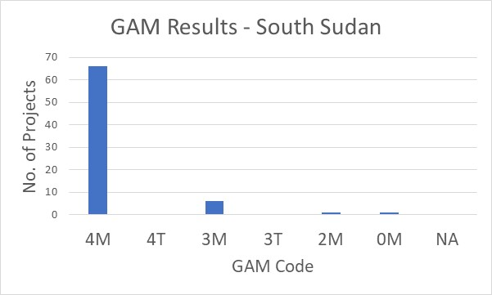
South Sudan GAM information summarized here demonstrates considerable attention to gender- and age-related issues in the project design phase, by those project holders using the tool.
Of the 74 projects applying the GAM, at 84% (66 projects) plan to respond to both gender and age differences (Code 4) throughout their program, and an additional six intend to address gender. There are only two projects that do not mainstream gender, and none for which gender differences are not applicable.

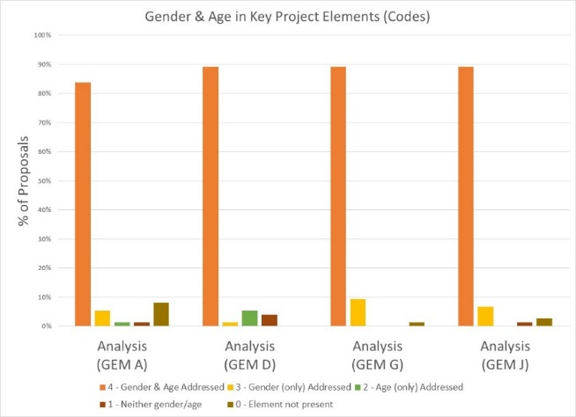
The GAM asks users to consider four program elements in project design: analysis, activities, participation and benefits.
In ALL of these areas, at least 84% of projects show intention to address gender and age differences in their projects.

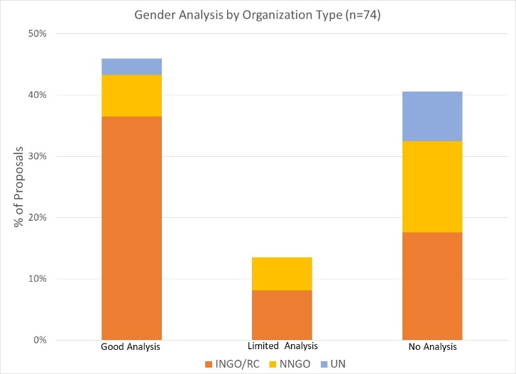
Almost half of projects (46%) demonstrate a good analysis of gender and/or age inequality in South Sudan. An additional 10% have a limited concept of analysis, expressing an intention to address inequality as opposed to an analysis of it, or citing disaggregated statistics often unrelated to their sector or activities. Many projects focus their analysis exclusively on gender-based violence. Thirty projects (approx. 40%) have no gender analysis.

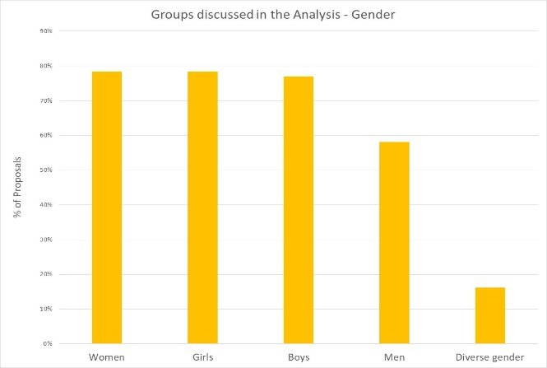
In their analysis, 50% of projects say they consider women, girls, boys and men. Overall, 80% of projects focus on women, girls and/or boys, and slightly less than 60% also specifically include men. 16% of projects (12) indicate that their analysis is concerned with people of diverse gender orientation/identity, but there may be confusion about the definition as this gender group is rarely mentioned in the narrative analyses.

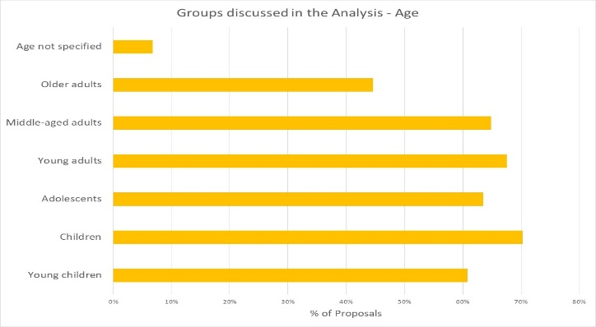
26% of projects indicate their analysis includes all age groups, while the majority are more selective. Only 45% of projects will specifically respond to older adults. Young children and adolescents are addressed by 61% and 64% of projects respectively. Five projects do not specify age groups of concern.

Support is needed to help project holders understand how and gender and age analysis can inform the activities to be delivered, how different groups can be engaged, or how results will be measured. Cluster coordinators can be involved to ensure partners share a common analysis of who is at risk in the crisis and why, and that they understand the implications of this for their project activities.

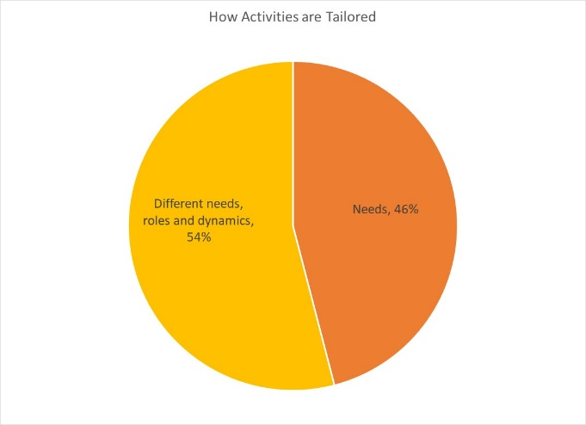
54% of projects plan to adapt or tailor their activities based on different gender-related needs, roles and dynamics, while 46% tailor activities based on different needs. There are no projects that constitute “targeted action” (Code T) to reduce gender barriers or discrimination; this is quite normal in humanitarian settings.

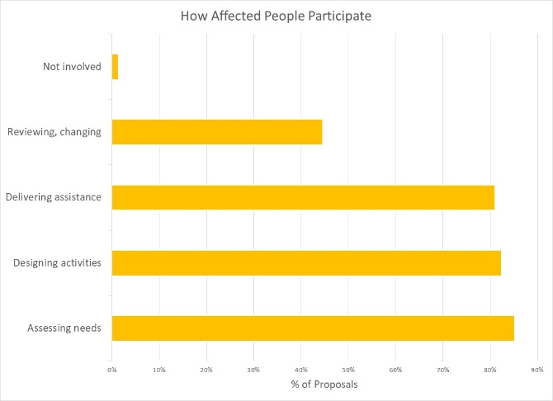
How affected people participate differs widely among projects and shows meaningful response. While 35% say affected people will be involved in all aspects of project management, most are more realistic. 36% of projects involve beneficiaries in three stages – assessment, design and delivery; only one project says people are not involved. The remaining 30% of projects select one or two aspects of project management where affected people will be involved. Affected people appear to be least involved in project review and revision.

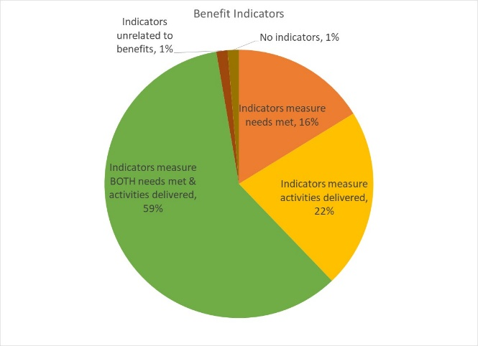
Reporting relative benefits
59% of projects say they will be able to provide disaggregated information on both the activities delivered, and the needs met. Smaller proportions (16% and 22% of projects) plan to report on either needs met or activities delivered, for different gender and age groups.

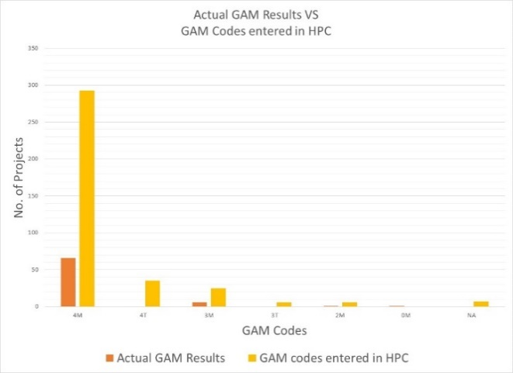
Summary
A total of 141 GAM forms were completed for South Sudan. There are 396 accepted projects in the South Sudan HPC; the IASC Gender with Age Marker was completed for 74 (19%) of the accepted projects. 38 additional HPC accepted projects appear to have a valid GAM Reference number, but users likely failed to press “submit” on completion, as the forms are not found in the GAM database. All 396 accepted HPC projects cite a GAM code, but most of these are not valid.

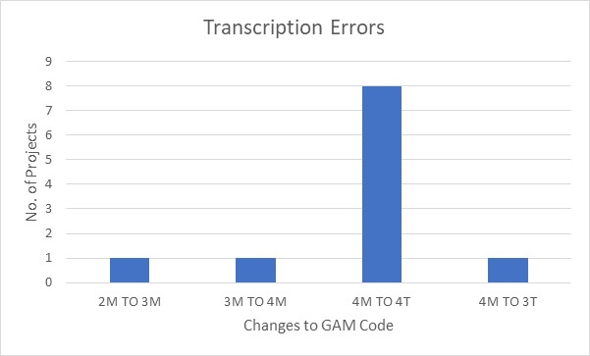
There were relatively few “transcription errors” when copying GAM codes into the HPC. These show that there may still be a misperception that a “targeted action” (T) is somehow better than a project that mainstreams gender (M). Nine projects changed their code from (M) to (T) when entering it in HPC tools; only two projects “upgraded” their code from 2 to 3, or 3 to 4.

It is impressive that the Gender with Age Marker was applied to so many GAM projects in South Sudan, given the lack of formal direction and “trained” GAM resource people or gender advisors involved in-country.
In addition to highlighting intent to address the needs of different groups in South Sudan, the GAM identifies areas where programming can be more responsive to gender- and age-related exclusion. There is clearly a need to support some clusters and organizations in developing a socio-economic (gender) context analysis and understanding its relevance to the design and delivery of assistance, but it is also clear that there is strong capacity for this among several actors in-country. There is also a need to inform UN Agencies about requirements for use of the GAM.
Use of the IASC Gender with Age Marker by humanitarian actors in South Sudan marks a shift toward delivering aid at new and higher standards. It is hoped that the support required for its ongoing use in project and program monitoring will be provided in the coming months.
It is intended that ALL projects accepted in the HPC will apply the IASC Gender with Age Marker prior to starting implementation. Follow-up reports will be provided as more South Sudan actors complete their GAM forms.

