Design Results – Sudan

Overview

42% (86/205) of Sudan projects “approved by cluster lead” in the 2019 HPC completed the IASC Gender with Age Marker. Sixty-two additional HPC accepted projects appear to have a valid reference number and may have used the GAM, but users likely failed to press “submit” on completion, as these forms are not found in the GAM database. Five organizations submitted the same GAM form for two projects. The GAM was not applied to 119 projects.
Compared to other countries, the GAM completion rate for Sudan is somewhat low, but not surprising given its recent introduction.
Sample GAM completion rates to date
 | Libya | Ukraine | Sudan | South Sudan | Nigeria | Palestine | Somalia
HPC Projects  Approved | 68 | 97 | 205 | 396 | 183 | 200 | 139
% with GAM | 75% | 76% | 42% | 19% | 25% | 79% | 61%

In this first year of use, it is important to continue to raise awareness of the purpose of the GAM.
The IASC Gender with Age Marker was designed in response to requests from the field for a tool that would help them understand HOW to do better gender equality programming. People knew they weren’t getting it right, but there was little practical advice on HOW projects could be improved.
The GAM offers 12 programming actions to improve attention to gender and age in projects and programs.
It is the process of discussing and answering the GAM questions about these programming actions that creates better projects (not the results that are achieved.) Ideally the GAM is used as a team planning or monitoring exercise.
Sudan GAM information summarized here demonstrates considerable attention to gender- and age-related issues in the project design phase, among those project holders using the tool.

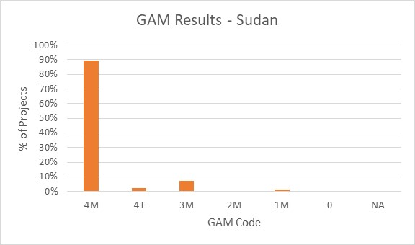
Of the 86 projects applying the GAM, 92% (79 projects) plan to respond to both gender and age differences (Code 4) throughout their program, and an additional six projects intend to address gender. Two projects are targeted actions (“T”) with a specific purpose to reduce inequality. There is only one project that does not mainstream gender. No projects determined that gender differences are not applicable (Code NA - they have no contact with or influence on services for affected people.)

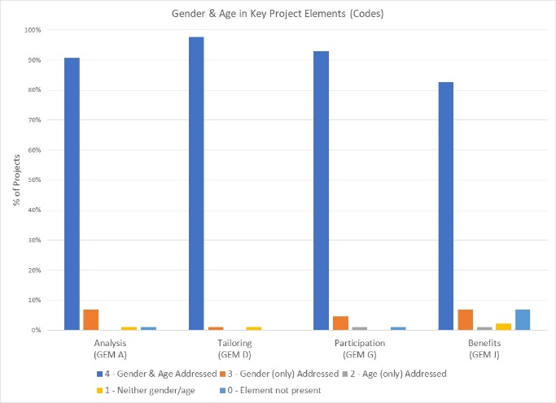
The GAM asks users to consider four program elements in project design: analysis, activities, participation and benefits.
In ALL of these areas, at over 80% of projects show intention to address gender and age differences in their projects.

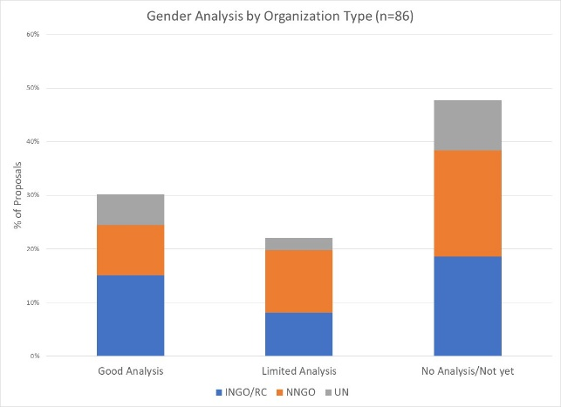
26/86 of projects with GAM forms (30%) demonstrate a reasonably good analysis of gender and/or age inequality in Sudan. 19 projects (22%) have a limited concept of analysis, expressing an intention to address inequality as opposed to an analysis of it, or citing disaggregated statistics often unrelated to their sector or activities. Several projects focus their analysis almost exclusively on gender-based violence. Almost half of Sudan projects (48%) do not have a gender analysis. These projects may need support to understand how the marginalization of certain groups will impact on delivery of their services.

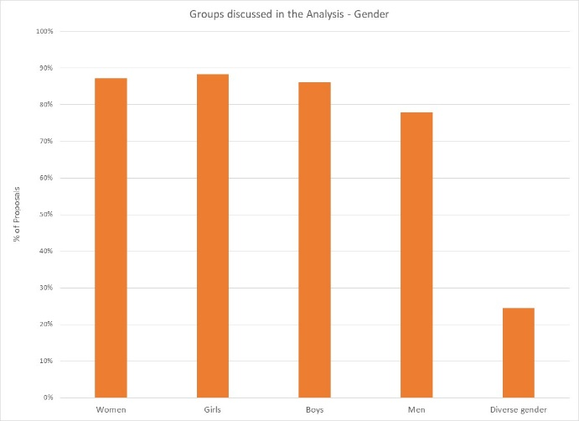
In their analysis, 55% of projects say they will consider women and girls and boys and men. Overall, women, girls and boys are a focus of analysis in 86% to 88% of projects, with men included slightly less often at 78%.
21 projects indicate that their analysis is concerned with people of diverse gender sexual orientation/ gender identity, but there may be confusion about definition as this gender group is not mentioned in the narrative analyses.

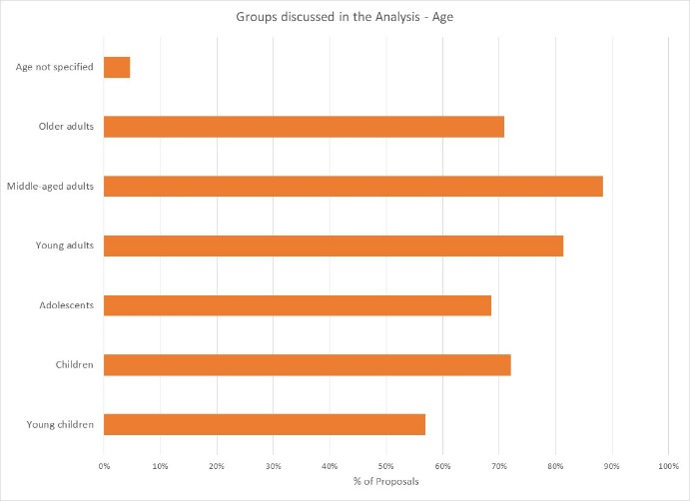
37% of projects indicate their analysis includes all age groups; the majority are more selective. Middle-aged adults and young adults are a focus of analysis in 88% and 81% of projects respectively; adolescents, children, and older adults are included in 69-72% of projects. Young children are part of the analysis in 57% of projects. Four projects do not specify age groups in their analysis.

Support is needed to help project holders understand how and gender and age analysis can inform the activities to be delivered, how different groups can be engaged, or how results will be measured. Cluster coordinators can be involved to ensure partners share a common analysis of who is at risk and why, and that they understand the implications of this for their project activities.
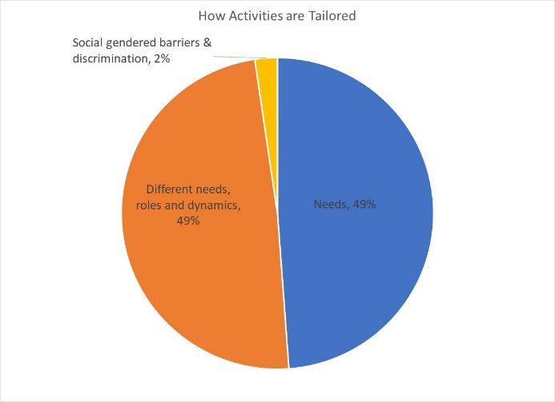
49% of projects plan to adapt or tailor their activities based on different gender-related needs, roles and dynamics, and 49% tailor activities based on the different needs. There are two projects that constitute “targeted actions” (Code T) to reduce gender barriers or discrimination; these are expected to be a very small proportion of projects in humanitarian settings.

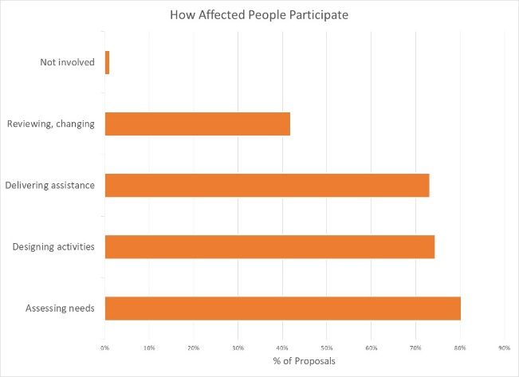
How affected people participate differs widely among projects and shows meaningful response. While thirteen projects say affected people will be involved in all aspects of project management, most are more realistic. The largest proportion of projects involve beneficiaries in assessing needs, followed by designing activities and delivering assistance. Only 42% of projects have beneficiaries involved in project review and revision. There is only one project where affected people will not be involved in any of these activities.

56% of projects intend for women, girls, boys and men to influence projects. 94% of projects intend to ensure women are involved in at least one aspect of project management, while 87% will involve men. Engagement of girls and boys is slightly lower at 78% of projects. 22% of projects indicate people of diverse gender/sexual orientation will be involved.

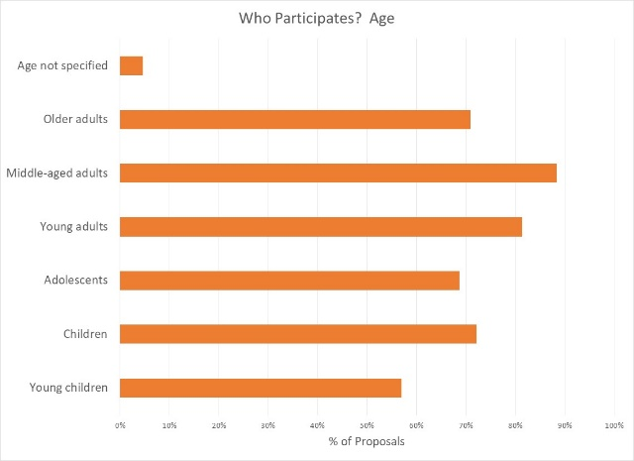

Participation by age groups reflects the concerns seen in the context analysis, with middle-aged and young adults expected to be the most engaged. Children, older adults, and to a slightly lesser extent adolescents are intended to participate. Young children will be the least involved.

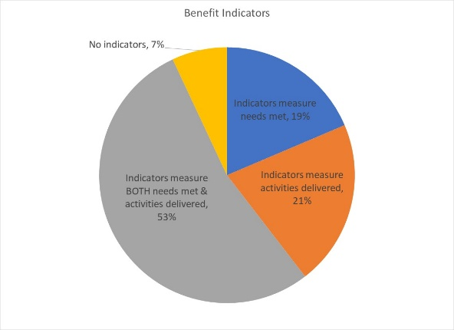
Reporting relative benefits
53% of projects say they will be able to provide disaggregated information on both the activities delivered, and the needs met. 21% of projects plan to report on the activities delivered, and 19% on the needs met for different gender and age groups. Six projects report no indicators yet.

Summary
It will be important to ensure that the remaining HPC approved projects apply the GAM before beginning implementation. The GAM can be applied several times, as project holders decide to review and adjust their programs. Users report that the GAM has drawn their attention to gender- and age-related concerns that might otherwise have been missed.
A total of 118 GAM forms were completed for Sudan, including 32 for projects that were not accepted in the HPC. There are 205 accepted projects in the HPC; the IASC Gender with Age Marker was completed for 86 (42%) of these. 62 additional accepted HPC projects cite a GAM reference number, but it appears that these users failed to actually “submit” the GAM form.
There 18 “transcription errors” when copying GAM codes into the HPC. These show that there may still be a misperception that a “targeted action” (T) is somehow better than a project that mainstreams gender (M). 11 projects changed their code from (M) to (T) when entering it in HPC tools, including three who also ‘upgraded’ their numeric code. Seven projects entered a lower numeric score in the HPC than actually received, possibly confused by the new 0-4 scale of the GAM as an optimum ‘score’ in the old gender marker was 2. The analysis in this report is based on the correct GAM scores in the GAM data base.
It is commendable that the Gender with Age Marker was applied to 42% of projects in Sudan, given the lack of formal direction from Agencies and few trained GAM resource people involved in-country.
In addition to highlighting overall strong desire to address specific needs of different groups, the GAM also identifies areas and agencies where programming can be more responsive to gender- and age-related exclusion. There is clearly a need to support some clusters and organizations in developing a socio-economic (gender) context analysis and understanding its relevance to how assistance is designed and delivered, but it is also clear that there is strong capacity for this among several actors in-country.
Use of the IASC Gender with Age Marker by humanitarian actors in Sudan shows a shift toward delivering aid at new and higher standards. It is hoped that the support required for its ongoing use in project and program monitoring will be provided. It is intended that ALL projects accepted in the HPC will apply the IASC Gender with Age Marker prior to starting implementation.
Follow-up reports will be provided as more Sudan actors apply the GAM to their project design and monitoring.

Oxfam America; Hope & Friendship for Development Organization; Gayat for Peace and Development/El Ruhama Organization; Business and Professional Women Organization; United Peace Organization

