Design Results – occupied Palestinian Territories

METHODOLOGY

Steps taken to compare and analyze HPC and GAM databases.

Step 1: Sort the HPC data by status “accepted”. There are 203 accepted projects for OPt.
Pull the correct GAM Code from GAM database into the HPC worksheet, using VLOOKUP on the GAM reference number. This shows projects with valid GAM reference number occurring in the HPC. (HPC Accepted Project column H)
There are 162 projects in the HPC a with valid GAM reference number. An additional 38 appear to have a GAM Reference number but do not appear in the GAM database (probably failed to press submit.)
Step 2: OPt GAMTool Datafile: There are 302 GAM forms in the GAM database for OPt.
Pull the HPC project ID number into the GAM database, using VLOOKUP on the GAM Reference Numbers. (Column B)
There are 162 GAMs with a valid HPC Project ID in the GAM database.
An additional 140 GAMs were completed, but these are for projects not found in the HPC.
Step 3: Double check - Pull the HPC line number for each project into GAM data, by matching the HPC Project ID from GAM database, with the line number where it occurs in the HPC. (=MATCH, Column C.) This confirms that projects with duplicate GAM forms are not found in the GAM database.

Overview

162/203 (80%) projects accepted in the 2019 HPC for the Occupied Palestinian Territories have completed the IASC Gender with Age Marker. An additional 38 HPC accepted projects appear to have a valid GAM Reference number, but users likely failed to press “submit” on completion, as these forms are not found in the GAM database. Three projects clearly did not apply the GAM.
There are 302 project records for oPt in the GAM database, 162 of these for HPC accepted projects.
The GAM completion rate for OPt is the highest of any country so far. This is particularly commendable given the lack of trained GAM resource people or gender advisors available in country. Success is to the credit of individual OCHA staff who made a significant effort to engage humanitarian partners in using the GAM.
Sample GAM Completion Rates (March 2019)
 | South Sudan | Libya | Ukraine | OPt | Palestine | Somalia | Nigeria
HPC Projects  Approved | 396 | 68 | 97 | 203 | 200 | 386 | 169
% with GAM | 19% | 75% | 76% | 80% | 79% | 25% | 26%

In this first year of use, it is important to continue to raise awareness of the purpose of the GAM.
The IASC Gender with Age Marker was designed in response to requests from the field, for a tool that would help them understand HOW to do better gender equality programming. People knew they weren’t getting it right, but there was little practical advice on HOW projects could be improved.
The GAM offers 12 programming actions to improve attention to gender and age in projects and programs.
It is the process of discussing and answering the GAM questions about these programming actions that creates better projects - not the specific results that are achieved. Ideally the GAM is used as a team planning or monitoring exercise.
OPt GAM information summarized here demonstrates considerable attention to gender- and age-related issues in the project design phase, among those project holders using the tool.

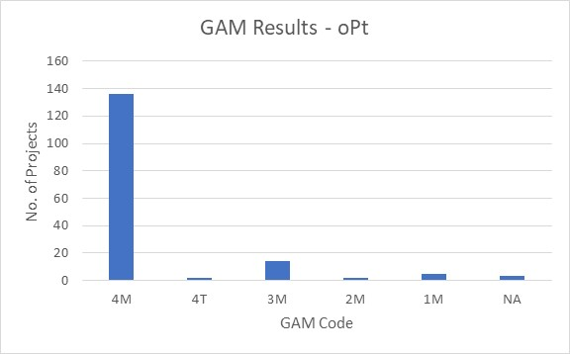
Of the 162 projects applying the GAM, 85% (138 projects) plan to respond to both gender and age differences (Code 4) throughout their program, and an additional 14 project intends to address gender (Code 3). 93% of projects mainstream attention to gender equality. Three projects indicate that gender differences are not applicable (Code N/A.)
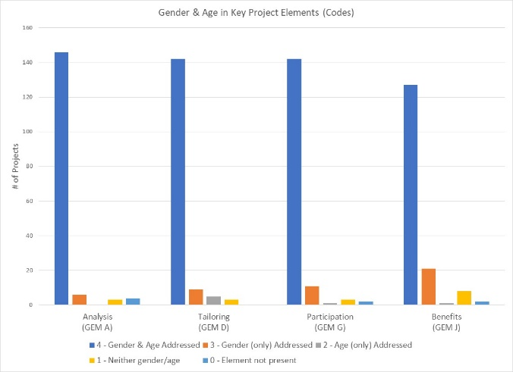

The GAM asks users to consider four program elements in project design: analysis, activities, participation and benefits.
In ALL of these areas, at least 127 projects (80%) show intention to address both gender and age differences

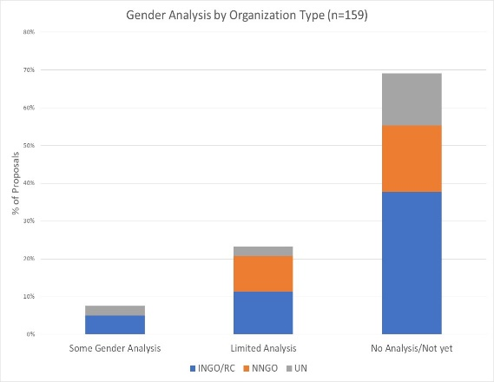
Logical, coherent programming is grounded in understanding who is marginalized or at risk, and why. It is not possible to provide an appropriate response without this analysis.
A rapid scan of GAM gender analysis narratives asked, “is there recognition of the different issues facing males and females?” The oPt narratives indicate project holders were advised to describe project plans and intentions for gender equality programming, rather than providing an analysis of the situation that their activities will respond to. Most projects present plans, often a list of activities/ outputs/targets, rather demonstrating their analysis of the situation.
When project holders articulate their analyses, ideally in consultation with clusters, they will then be able to check that activities and methods are consistent with and responsive to the analysis. At present only 31% of oPt projects describe a situation of inequality, although almost all of them explain how they intend to respond to it.

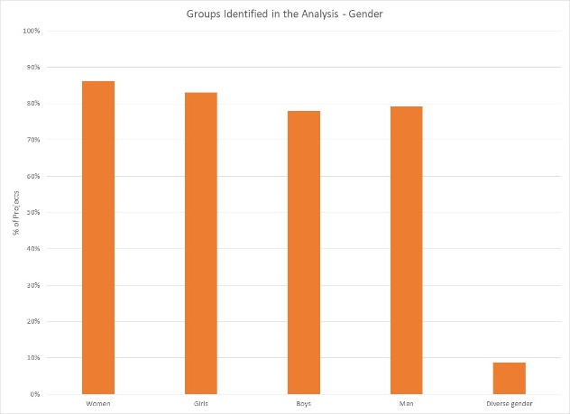
62% of oPt projects say they consider women, girls, boys and men in their analysis. Overall, there is little variation in focus with 78% to 86% of projects considering one or more of these gender groups. Fourteen projects indicate that their analysis is concerned with people of diverse gender sexual orientation/ gender identity, but there may be confusion about the definition as this gender group is not mentioned in any of the narrative analyses.

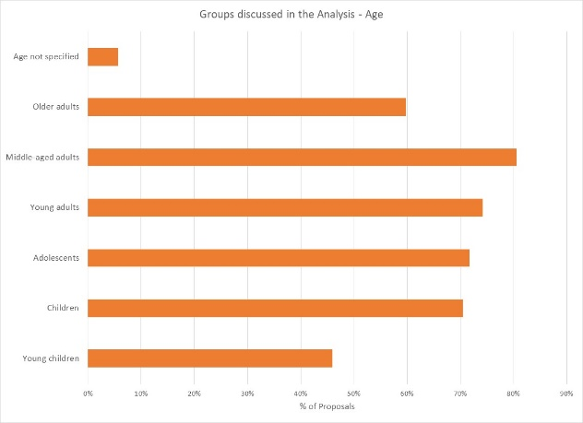
31% of projects indicate their analysis includes all age groups; the majority are more selective. Middle-aged adults are the focus of analysis in 81% of projects; young adults, adolescents and children are included in 70% to 74% of projects. A smaller proportion of projects specifically look at the situation of older adults, young children. Nine projects do not specify age groups in their analysis.

Support is needed to help project holders understand how and gender and age analysis can inform the activities to be delivered, how different groups can be engaged, or how results will be measured. Cluster coordinators can be involved to ensure partners share a common analysis of who is at risk and why, and that they understand the implications of this for their project activities.

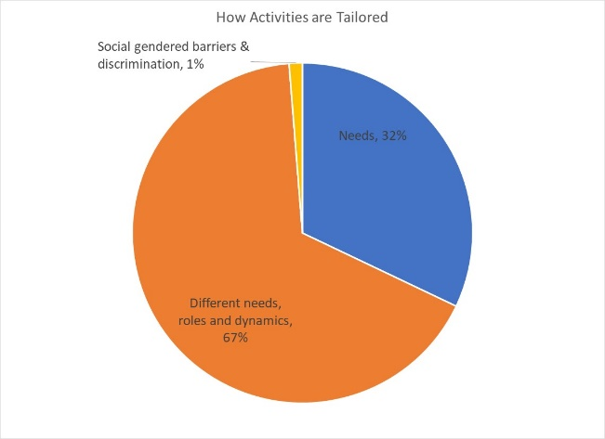
67% (106/159) of projects plan to adapt or tailor their activities based on different gender-related needs, roles and dynamics, while 32% (51/159) tailor activities based on the different needs. Two projects are “targeted actions” (Code T) aimed to reduce gender barriers or discrimination; there are usually very few such projects in humanitarian settings.

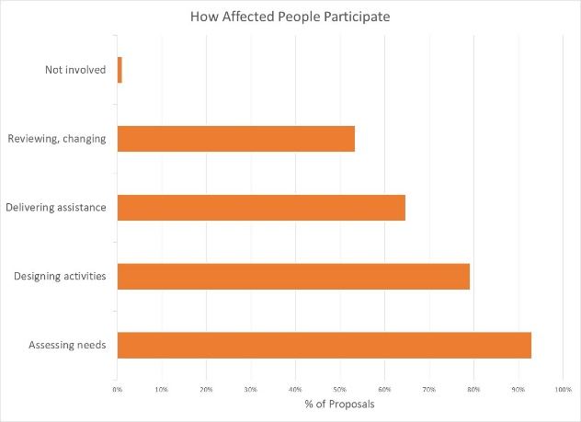
How affected people participate differs widely among projects and shows meaningful response. While 43% (68 projects) say affected people will be involved in all aspects of project management, most are more realistic. The largest proportion of projects involve beneficiaries in assessing needs followed by activities design. A smaller proportion of projects have beneficiaries involved in assistance delivery, and only 53% say they will be involved in project review and revision. There are two projects where affected people will not be involved in any of these activities.

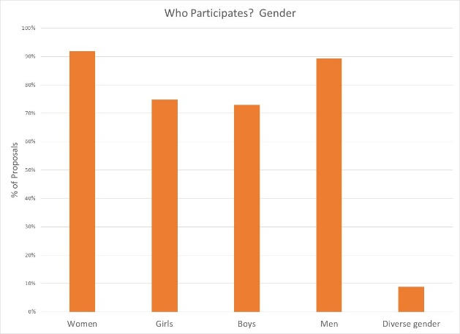

Women and men will be influencing at least one aspect of project management in 92% and 89% of projects respectively; girls and boys are expected to be less involved. Fourteen projects expect the participation of people of diverse gender/sexual orientation.

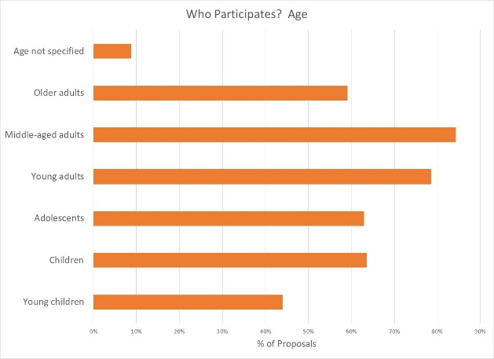
Participation by age groups seems similarly well-thought. It is likely that most people influence project management will be middle-aged and young adults; it is encouraging to see several projects intending for children and adolescents to have an active role. Lowest levels of participation are by older adults and young children; while the latter is probably realistic, one hopes more might be done to engage with the elderly.

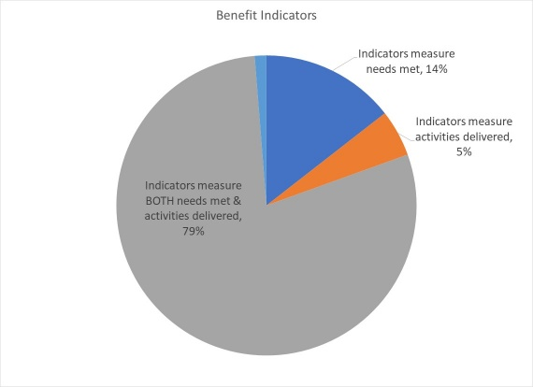
Reporting relative benefits
No indicators, 1%
126 projects (79%) say they will be able to provide disaggregated information on both the activities delivered, and the needs met. Smaller numbers of projects (14% and 5% respectively) plan to report on either needs met or activities delivered, for different gender and age groups. Two projects (1%) report no indicators yet.

Summary
It will be important to ensure that all HPC approved projects apply the GAM before beginning implementation. The GAM can be applied several times, as project holders review and make adjustments to their programs. Users report that the GAM has drawn their attention to gender- and age-related concerns that might otherwise have been missed.
A total of 302 GAM forms were completed for OPt, including 140 for projects that were not accepted in the HPC. There are 203 accepted projects in the HPC; the IASC Gender with Age Marker was completed for 162 (80%) of these. 38 additional accepted HPC projects cite a GAM reference number (including one duplicate) but it appears that these users failed to actually “submit” the GAM form.
There were thirteen “transcription errors” when copying GAM codes into the HPC. These show that there may still be a misperception that a “targeted action” (T) is somehow better than a project that mainstreams gender (M). Seven projects changed their code from (M) to (T) when entering it into HPC tools, including three who also ‘upgraded’ their numeric code. Six projects entered a higher numeric score in the HPC than actually received when they completed the GAM. The analysis in this report is based on the correct GAM scores in the GAM data base.
It is commendable that the Gender with Age Marker was applied to such a high percentage of oPt projects, given the lack of formal direction from Agencies and few trained GAM resource people involved in-country. This is entirely due to the commitment and motivation of individuals in OCHA and other agencies.
In addition to highlighting overall strong desire to address specific needs of different groups in OPt, the GAM also identifies areas and agencies where programming can be more responsive to gender- and age-related exclusion. There may be a need to support some clusters and organizations in developing a socio-economic (gender) context analysis and understanding its relevance to how assistance is designed and delivered, but it is also clear that there is strong capacity for this among several actors in-country.
Use of the IASC Gender with Age Marker by humanitarian actors in OPt shows a shift toward delivering aid at new and higher standards. It is hoped that the support required for its ongoing use in project and program monitoring will be provided. It is intended that ALL projects accepted in the HPC will apply the IASC Gender with Age Marker prior to starting implementation. Follow-up reports will be provided as more OPt actors complete their GAM forms. Further details (e.g. GAM analysis at agency or cluster level) can be provided on request.

