Design Results – Syria

Overview

454/664 (68%) projects accepted in the 2019 HPC for Syria have completed the IASC Gender with Age Marker. An additional xx HPC accepted projects appear to have a valid GAM Reference number, but users likely failed to press “submit” on completion, as these forms are not found in the GAM database. Three projects clearly did not apply the GAM.
There are 561 project records for Syria in the GAM database, 107 of these are for projects not accepted in the HPC.
Given the scale of the appeal for Syria, a completion rate of 68% is highly commendable, especially given the lack of trained GAM resource people or gender advisors available in country. Success is to the credit of individual OCHA staff and UN agency staff who made a significant effort to engage humanitarian partners in using the GAM.
Sample GAM Completion Rates (March 2019)
 | South Sudan | Libya | Ukraine | Syria | Palestine | Somalia | Nigeria
HPC Projects  Approved | 396 | 68 | 97 | 664 | 200 | 386 | 169
% with GAM | 19% | 75% | 76% | 68% | 79% | 25% | 26%

In this first year of use, it is important to continue to raise awareness of the purpose of the GAM.
The IASC Gender with Age Marker was designed in response to requests from the field, for a tool that would help them understand HOW to do better gender equality programming. People knew they weren’t getting it right, but there was little practical advice on HOW projects could be improved.
The GAM offers 12 programming actions to improve attention to gender and age in projects and programs.
It is the process of discussing and answering the GAM questions about these programming actions that creates better projects - not the specific results that are achieved. Ideally the GAM is used as a team planning or monitoring exercise.
Syria GAM information summarized here demonstrates considerable attention to gender- and age-related issues in the project design phase, among those project holders using the tool.

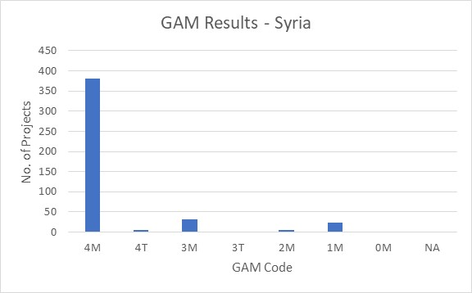
Of the 454 projects applying the GAM, 85% (386 projects) plan to respond to both gender and age differences (Code 4) throughout their program, and an additional 34 project intends to address gender (Code 3). 91% of projects mainstream attention to gender equality. 7 projects are targeted actions with a primary purpose of addressing inequality and discrimination. Two projects indicate that gender differences are not applicable (Code N/A.)

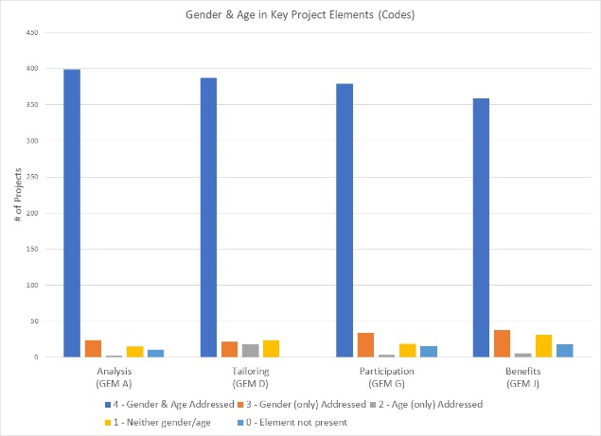
The GAM asks users to consider four program elements in project design: analysis, activities, participation and benefits.
In ALL of these areas, at least 359 projects (79%) show intention to address both gender and age differences

Logical, coherent programming is grounded in understanding who is marginalized or at risk, and why. It is not possible to provide gender-responsive action without this analysis.

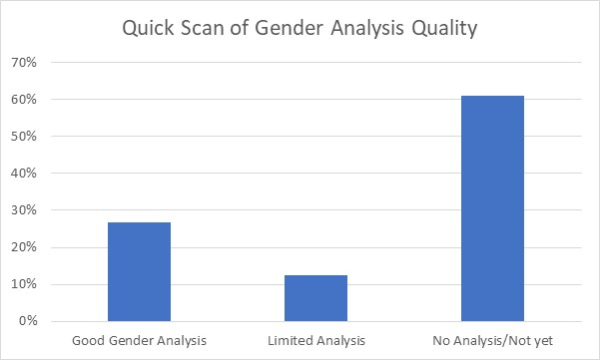
A rapid scan of GAM gender analysis narratives asked, “is there recognition of the different issues facing males and females?” The Syria narratives indicate project holders thought they should describe project plans and intentions for gender equality programming, or their targeting criteria, rather than providing an analysis of the situation that their activities will respond to. Most projects present plans, often a list of activities/ outputs/targets, rather demonstrating an analysis of the situation.

When project holders articulate their analyses, ideally in consultation with clusters, they will then be able to check that activities and methods are consistent with and responsive to the analysis. At present less than% of Syria projects describe a situation of inequality, although almost all of them explain how they intend to respond to it.

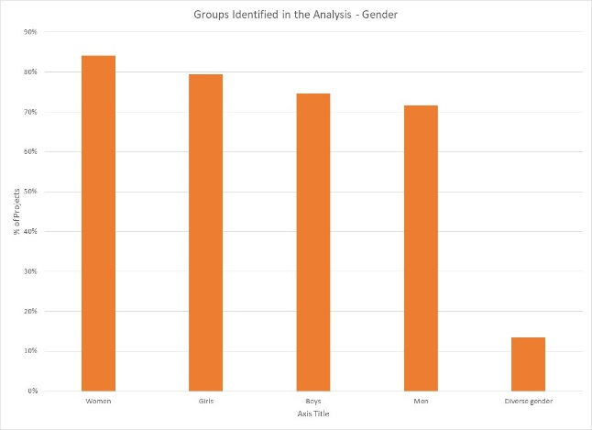
55% of Syria projects say they consider women, girls, boys and men in their analysis. Overall, there is little variation in focus with 72% to 84% of projects considering one or more of these gender groups. 61 projects indicate that their analysis is concerned with people of diverse gender sexual orientation/ gender identity, but there may be confusion about the definition as this gender group is not mentioned this frequently in the narrative analyses.

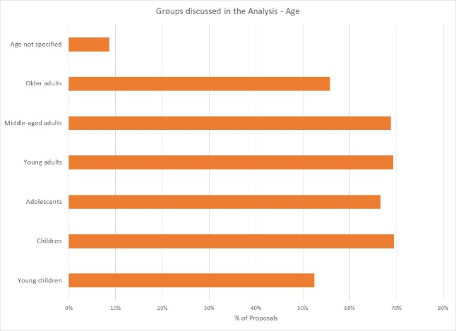
35% of projects indicate their analysis includes all age groups; and there is little variation among those more selective. 67% to 69% of projects indicate that one or more of children, adolescents, young- and middle-aged adults are a focus of analysis. A smaller proportion of projects specifically look at the situation of older adults and young children. 39 projects do not specify age groups in their analysis.

Support is needed to help project holders understand how and gender and age analysis can inform the activities to be delivered, how different groups can be engaged, or how results will be measured. Cluster coordinators can be involved to ensure partners share a common analysis of who is at risk and why, and that they understand the implications of this for their project activities.

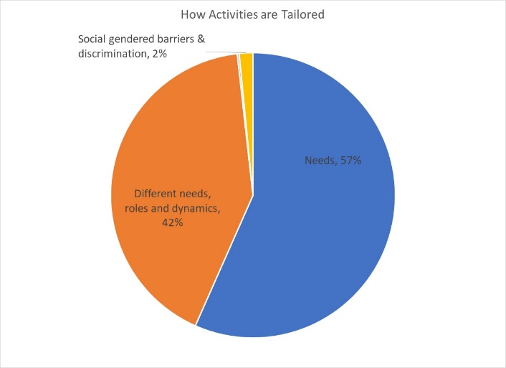
42% (188/452) of projects (188/452) plan to adapt or tailor their activities based on different gender-related needs, roles and dynamics, while 57% (256 projects) tailor activities based on the different needs. Seven projects are “targeted actions” (Code T) aimed to reduce gender barriers or discrimination; there are usually very few such projects in humanitarian settings.

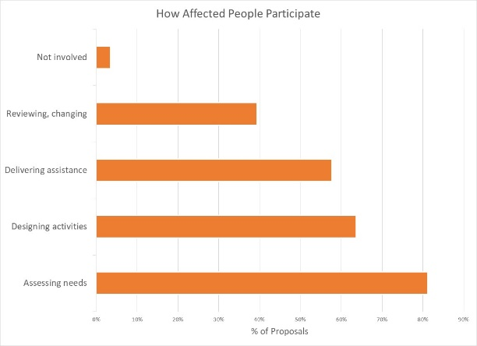
How affected people participate differs widely among projects and shows meaningful response. While 28% (126 projects) say affected people will be involved in all aspects of project management, most are more realistic. The largest proportion of projects involve beneficiaries in assessing needs followed by activities design. A smaller proportion of projects have beneficiaries involved in assistance delivery, and only 39% say they will be involved in project review and revision. There are sixteen projects where affected people will not be involved in any of these activities.

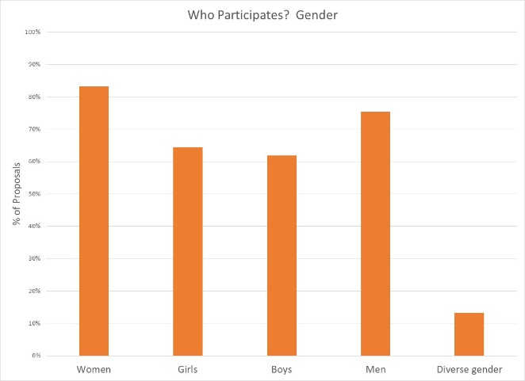

Women and men will be influencing at least one aspect of project management in 83% and 75% of projects respectively; girls and boys are expected to be less involved. Sixty projects expect the participation of people of diverse gender/sexual orientation.

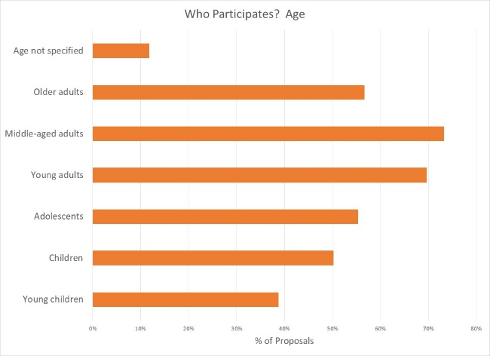

Participation by age groups seems similarly well-thought. It makes sense that most people influencing project management will be middle-aged and young adults; it is encouraging to see more than half of projects intending for older adults, adolescents and children to have an active role. Lowest levels of participation are by children and young children. 53 projects do not specify age groups.

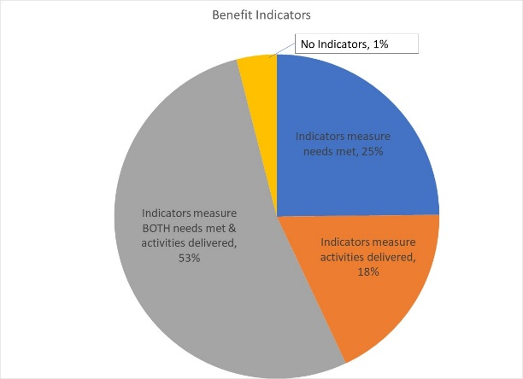
Reporting relative benefits
No indicators, 1%
239 projects (53%) say they will be able to provide disaggregated information on both the activities delivered, and the needs met. Smaller proportions of projects (25% and 18% respectively) plan to report on either needs met or activities delivered, for different gender and age groups. 18 projects (4%) report no indicators yet.

Summary
It is commendable that the Gender with Age Marker was applied to so many projects in Syria, given the lack of formal direction from Agencies and few trained GAM resource people involved in-country. In addition to highlighting intention to address the needs of different groups in Syria, the GAM also identifies areas and agencies where programming can be more responsive to gender- and age-related exclusion. There is a clear need to support some clusters and organizations in developing a socio-economic (gender) context analysis and understanding its relevance to how assistance is designed and delivered, but it is also clear that there is strong capacity for this among several actors in-country.
A total of 561 GAM forms were completed for Syria, including 107 for projects that were not accepted in the HPC. There are 664 accepted projects in the HPC; the IASC Gender with Age Marker was completed for 454 (68%) of these. 210 additional accepted HPC projects do not yet have a completed Gender with Age Marker.
24 projects of the accepted projects applied the GAM form for monitoring, instead of for project design. These provide much more concrete information on specific programming actions and will be analyzed separately. In the interim, information has been incorporated into the current design phase analysis.
15% of Syria GAM codes were incorrectly copied into the HPC. There were 68 “transcription errors,” suggesting misunderstanding of the purpose of the exercise. There is clearly a misperception that a “targeted action” (T) is somehow better than a project that mainstreams gender (M): 47 projects changed their code from (M) to (T) when entering it into HPC tools. Whether a project mainstreams gender or is a targeted action to address inequality is determined automatically by the answers selected.
Only 11 projects “upgraded” their numeric code when copying it into the HPC. 23 projects entered a lower number in HPC, possibly due to confusion with the old gender marker coding system where “2” was the optimum (required) score. The analysis in this report is based on the correct GAM scores in the GAM data base.
For the GAM is to have its intended impact on project quality, it must be clear that the code received is in no way tied to project acceptance or funding. It is the process of completing the GAM that improves the quality of action; evidence is only required that the process has been completed. Users should have no incentive to alter the received scores intended for their benefit only.

13 organizations submitted the same GAM for multiple (37) projects. The purpose of the tool is for teams to reflect specifically about the relevant gender- and age- related dimensions of each project and its activities, which of course cannot be done with token or “cookie cutter” approaches. The same GAM Reference cannot be used for more than one project.
Use of the IASC Gender with Age Marker by humanitarian actors in Syria shows a shift toward delivering aid at new and higher standards. Users report that the GAM draws attention to gender- and age-related concerns that might otherwise have been missed.
It is important that ALL projects accepted in the HPC will apply the IASC Gender with Age Marker prior to starting implementation. The GAM can be applied several times, as project holders decide to review and adjust their programs. It is hoped that the support required for its ongoing use in project and program monitoring will be provided.
Follow-up reports will be provided as more Syria actors complete their GAM forms. Further details (e.g. GAM analysis at agency or cluster level) can be provided on request.

METHODOLOGY

(Steps taken to compare and analyze HPC and GAM databases.)

Step 1: Sort the HPC data by status “accepted”. There are 664 accepted projects for Syria.
Pull the correct GAM Code from GAM database into the HPC worksheet, using VLOOKUP on the GAM reference number. This shows projects with valid GAM reference number occurring in the HPC. (HPC Accepted Project column H)
There are 478 projects in the HPC a with valid GAM reference number. 26 are duplicates, where a single GAM form has been submitted for more than one project. There are 454 valid GAM forms.
An additional 132 appear to have a GAM Reference number (including 3 duplicates) but do not appear in the GAM database (probably failed to press submit.)
Step 2: Syria GAMTool Datafile: There are GAM forms in the GAM database for Syria.
Pull the HPC project ID number into the GAM database, using VLOOKUP on the GAM Reference Numbers. (Column B)
There are 561 GAM completed forms in the GAM database; 454 GAMs of these have a valid HPC Project ID in the GAM database.
Step 3: Double check - Pull the HPC line number for each project into GAM data, by matching the HPC Project ID from GAM database, with the line number where it occurs in the HPC. (=MATCH, Column C.) This confirms that projects with duplicate GAM forms are not found in the GAM database.

