GAM Results:
Burkina Faso

Overview
There are 95 approved projects in the Burkina Faso 2020 HPC; 58 of these have have a valid GAM reference number. Four organizations submitted the same GAM for two projects (Oxfam, WFP, ACF, Solidarités), leaving 54 projects (57%) with a completed GAM. (The IASC target for GAM completion is 80% of country projects.)
A total of 82 projects in Burkina Faso have completed the IASC Gender with Age Marker, and 54 of them are found in the HPC. 52 used it for project design and 2 for project monitoring; one project (UN OCHA) gender is “not applicable” to their work.
There were 12 transcription errors when copying the GAM Code into HPC:
- 8 projects changed the project focus from M to T
- 3 projects “upgraded” the numeric code
- 2 downgraded the code from 4 to 3 (possibly confusing with other markers where the optimum code is 3,) also changed M to T
- 1 project changed the code from T to M
These are errors important as they suggest misunderstanding of the purpose of the GAM. There is a misperception that a “targeted action” (T) is somehow better than a project that mainstreams gender (M): this is simply incorrect. Whether a project mainstreams gender or is a targeted action to address inequality is determined automatically by the answers selected. The errors also suggest users believe the code received is in some way tied to project acceptance or funding, which it is most definitely is not the case!
The design phase of the GAM asks users to consider four essential programming actions that contribute towards gender and age inclusion: analysis, tailoring of activities, participation, and benefits. The monitoring phase asks users to report on these four, plus eight additional indicators.
Design & Monitoring | Monitoring Only
- Analysis | - Data Disaggregation | - Targeting
- Tailoring of Activities | E. Gender-based Violence | F. Coordination
G. Influence (Participation) | H. Feedback & Complaints | I. Communication (Transparency)
J. Benefits | K. Satisfaction | L. Project Problems

In this first year of use, it is important to continue to raise awareness of the purpose of the GAM.
The IASC Gender with Age Marker was designed in response to requests from the field for a tool that would help humanitarians understand HOW to do better gender equality programming. People knew they weren’t getting it right, but there was little practical advice on HOW projects could be improved.
The GAM can be described as a “learning by doing” tool, based on the premise that systematically thinking about and responding the questionnaire will result in more inclusive and responsive projects. It is the process of discussing and answering GAM questions about the twelve programming actions that creates better projects - not the results that are achieved. Ideally the GAM is used as a team planning or monitoring exercise.
This report covers ALL GAM submission for Burkina Faso, not only those projects accepted for the 2020 HPC. A separate analysis can be done for this if required. GAM information summarized here demonstrates considerable attention to gender- and age-related issues, as well as several questions for further reflection and discussion among project holders using the tool.
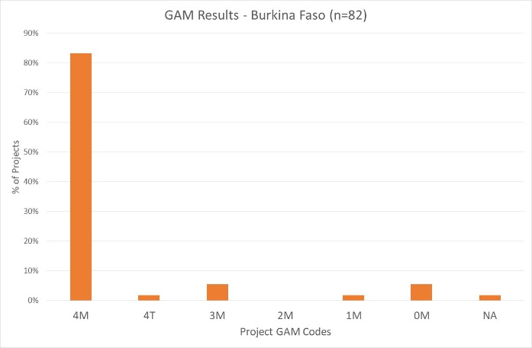
Of the 81 Burkina Faso projects completing the GAM, 85% (46 projects) plan to respond to both gender and age differences (Code 4), including one targeted action (“T”) with the specific purpose to reduce inequality. 3 projects intends to address gender (but not age) differences. There are also five projects that do not mainstream gender and/or age.

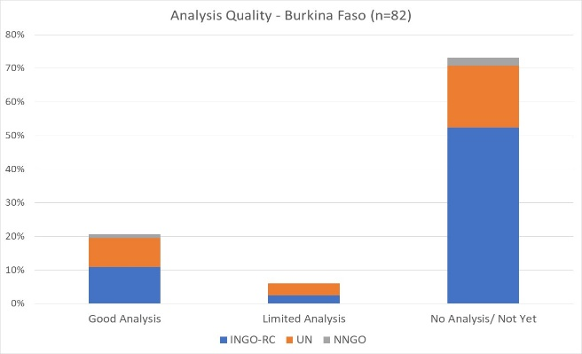
A very cursory scan of GAM submissions suggests only 21% of projects are able to ariculate and give examples of gender differences that affect how assistance is delivered. This is determined by Column Y of the Burkina Faso GAM data, where project holders are asked to describe their gender analysis. Based on rapid review, projects that clearly describe or provide an example of role and/or power differences (“gender analysis”) are coded green. 6% of Burkina Faso projects have a limited (yellow - 5 projects) or no gender analysis (red-60 projects, 63%.)
These projects most often describe their policy or program, a commitment to address inequality rather than explanation of actual differences in the context. This reflects a common misunderstanding of tool: its purpose is not to persuade others of the value of a project, but rather an opportunity for project holders to articulate and confirm the relevance and coherence of their program actions.
Support may be needed to help project holders understand how and gender and age analysis can inform the activities to be delivered, how different groups can be engaged, or how results will be measured. OCHA and cluster management can be involved to ensure project teams share a common analysis of who is at risk and why, and that they understand the implications of this for their project activities.
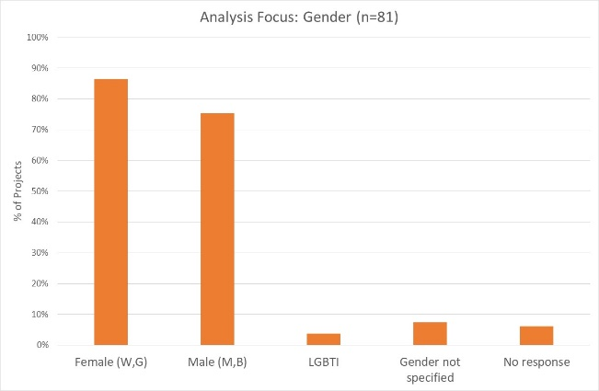
63% of projects say their analysis is concerned both females and males. Separately, 86% of projects consider females, and 75% males. 3 projects (4%) indicate their analysis is concerned with people of diverse gender sexual orientation/ gender identity (LGBTI).

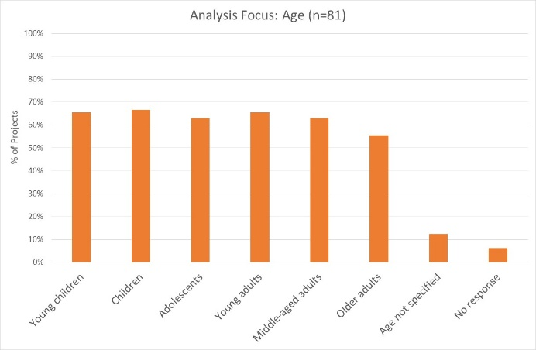
40% (32 projects) indicate their analysis is concerned with all age groups. Attention to different age groups appears quite balanced among projects, although older adults are a focus of analysis in slightly fewer (56%.) It should be noted however, that issues affecting the prioritized gender and age groups are not always reflected in the analysis.

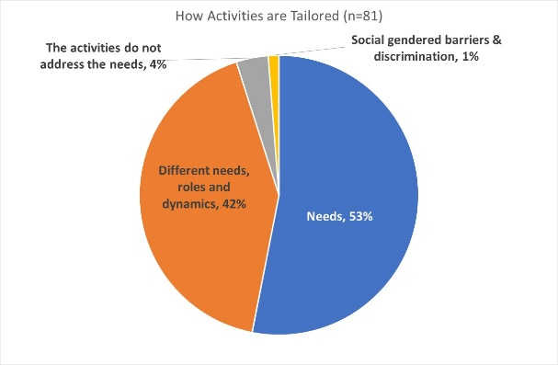
Tailoring Activities for different groups: 42% of projects plan to tailor activities according to the needs, roles and dynamics of different groups, while 53% tailor activities only according to needs. One project is a “targeted action” (Code T) with activities designed to reduce gender barriers or discrimination; these are normally a very small proportion of projects in humanitarian settings.
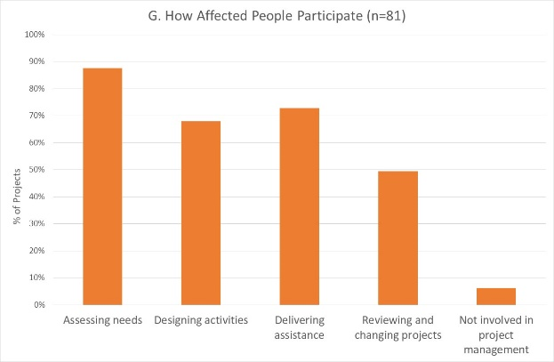
35% of projects intend to involve affected people in all stages of project management, but many are more selective. Almost 90% of projects intend to involve beneficiaries in needs assessment, and 73% in delivering assistance. Participation is expected to be lower in activities design, and less than 50% will be engaged in project review and revision. There are only 5 projects where affected people will not be involved in any of these activities.

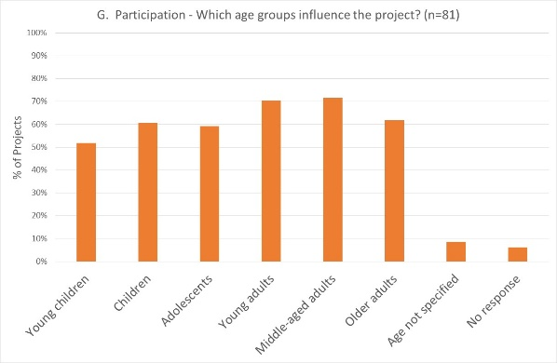
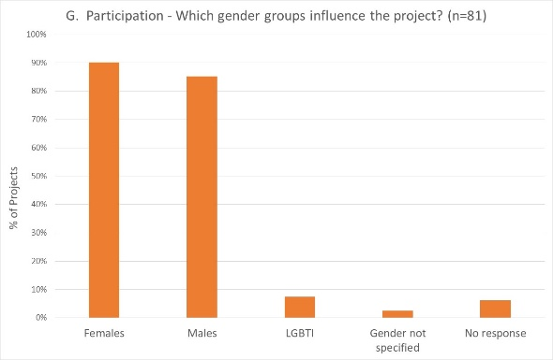
Females and males are both expected to participate and influence management, in 90% and 85% of projects respectively. 3 projects indicate that people of diverse gender/sexual orientation (LGBTI) will be involved, but this is not consistent with other information provided. 50% or more projects expect participation of different age groups. While children and young children may be logically less involved, it may be helpful to check that adolescents and older adults are being engaged as fully as possible.
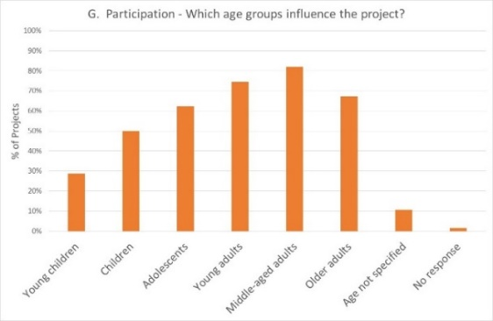

Reporting relative benefits
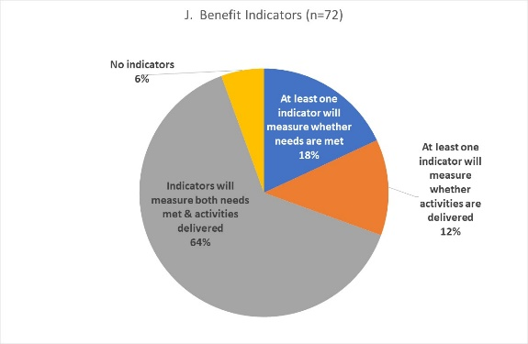
Of the 72 projects using the GAM for project design, 64% say they will be able to provide disaggregated information on both the activities delivered, and the needs met. A further 18% plan to report on needs met, and 9 projects (12%) to report on activities delivered. Over 80% of projects will provide results disaggregated by sex, and 58% will disaggregate results for one or more age groups.

Project Monitoring
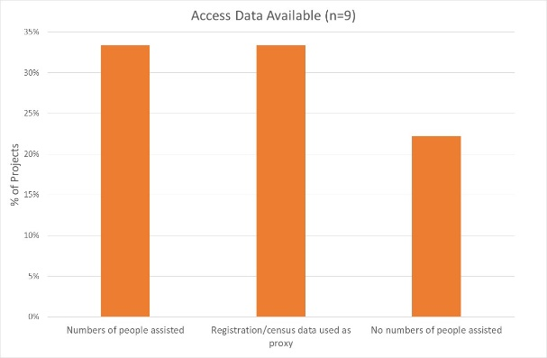
Only 9 Burkina Faso projects have used the GAM for monitoring, a very small sample. However, responses still serve to demonstrate the future utility of the GAM, particularly its ability to describe accountability and protection in the monitoring phase, including for specific gender and age groups. A brief look at the monitoring results shows the type of information that will be available, and the importance of global reporting on these results.
Access to Assistance:
Only 3/9 projects report data on the actual numbers of people assisted, while 3/9 use registration or census data to estimate access. Two projects say they have no information on numbers of people assisted. Seven projects indicate data is disaggregated by sex for one or more age groups.

Targeting:
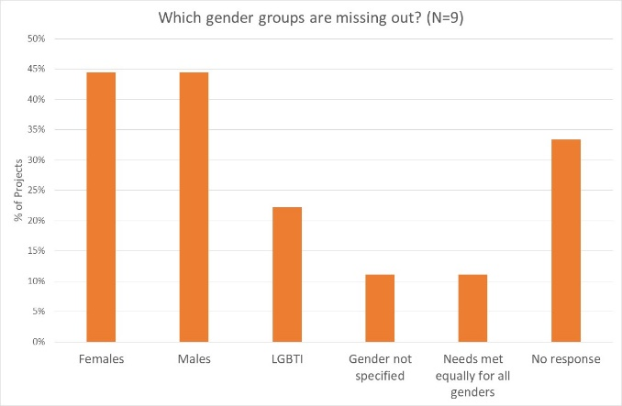
6/9 projects report that people access aid as planned, while 3/9 did not have targets for different gender or age groups. Only one project reports that needs were met equally for all gender, and two say met equally for all age groups; most identify one or more groups as possibly missing out. Three projects did not answer these questions.
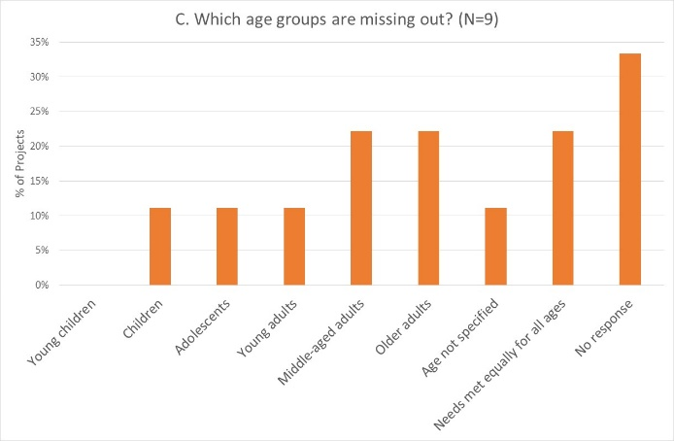

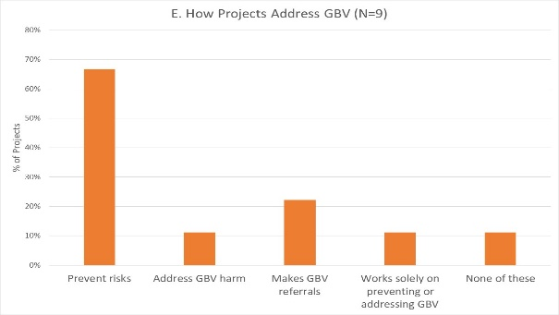
Gender-based violence:
6/9 projects work to prevent risk of GBV, while two respond to GBV in other ways. Only one project has no involvement with GBV prevention or response.

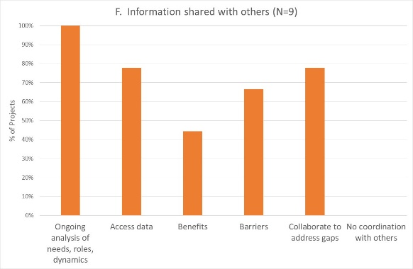
Coordination:
All nine projects indicate that they share ongoing analysis within their clusters; most also share information and collaborate in other areas.
4 projects share information disaggregated by sex and age; 3 disaggregate by sex only, and 2 do not disaggregate their shared data.

Complaints and Feedback mechanisms: 7/9 projects have at least one way for people to complain, and 3 projects say that complaints result in changes; only one reports that procedures are safe and confidential. One project has different procedures for female and males, while 6 indicate that procedures are the same for all groups.
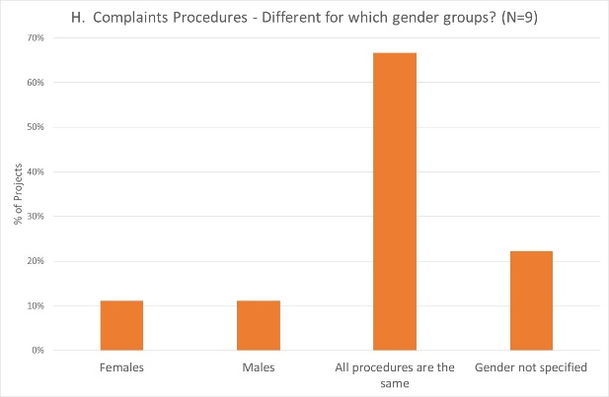
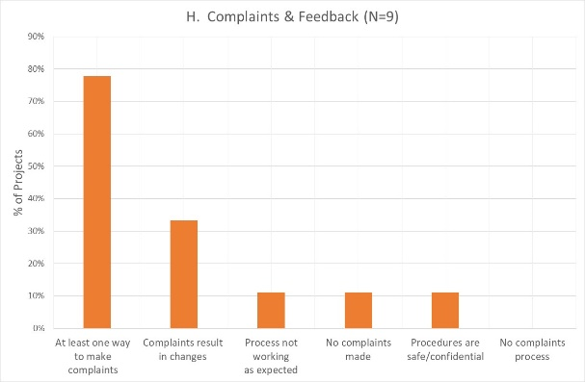

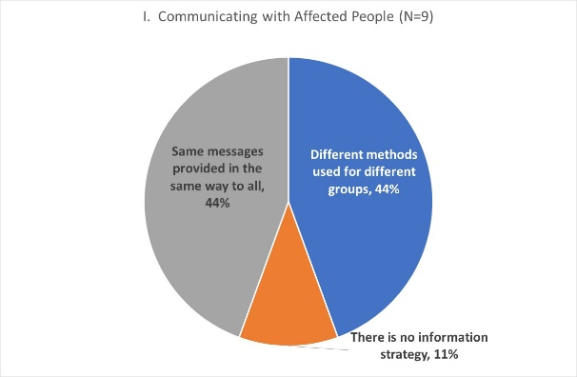
Communication with Communities/Transparency:
4/9 projects using the GAM for monitoring in Burkina Faso tailor their communication and messages for different gender and/or age groups; 4/9 provide the same messages in the same way to everyone. One project indicates no strategy in this area.

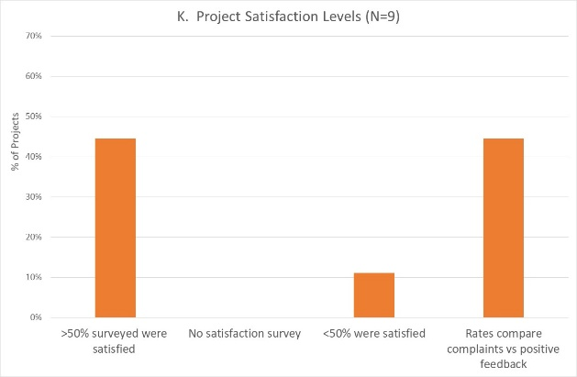
Satisfaction:
4/9 projects indicate more than 50% of beneficiaries were satisfied with the assistance, and only one with less than <50% satisfied. However, four projects indicate that they estimate satisfaction levels based on complaints received, which seems more likely than the use of formal satisfaction surveys. There were high ‘no response’ levels for questions on satisfaction, gender and age.

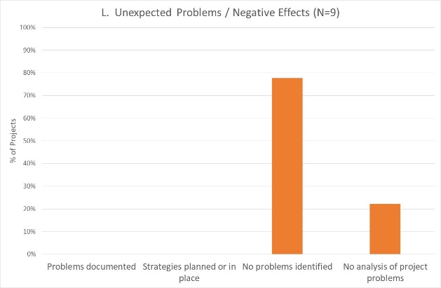
Dealing with negative effects:
Both projects say no unexpected problems have been identified in monitoring, and consequently do not respond about which gender and/or age groups may have been more adversely affected.

Conclusion
GAM response quality is improving with organizational interest and management review of GAM content, and understanding that attributable information is reported globally. While this overview of GAM use in Burkina Faso demonstrates its potential for supporting projects to provide relevant and responsive assistance for different groups, the data should be viewed with caution. There is some evidence that the questionnaire is not always completed by an informed respondent.
Even this limited sample provides evidence and examples of what projects are doing well, where good programming capacity exists, and where support can be provided. An excellent starting point for gender advisors and focal points is Column Y of the GAM database (Worksheet ‘Burkina Faso’), where organizations currently unable to articulate a simple gender analysis can be assisted to understand why this is fundamental to designing and implementing a gender-responsive project.
It will be important that all Burkina Faso FTS projects (including the 41 HPC projects that have not yet applied the GAM in project design) apply the GAM for monitoring. This can be done at any time during implementation, and will provide an important overview of accountability and inclusion in the Burkina Faso response.

27 March 2020

