GAM Results:
2019 Iraq FTS Projects

Overview
There are 175 projects in the Iraq 2019 FTS; 127 (73) of these have have a valid GAM reference number. One organization submitted the same GAM for two projects, leaving 126 projects with a completed GAM.
A total of 292 projects in Iraq have completed the IASC Gender with Age Marker, with 126 of them found in the FTS. 123 have used it for project design, and 3 for project monitoring; four of these claim gender is “not applicable” to their work.
There were 16 transcription errors when copying the GAM Code into FTS:
- 6 projects changed the project focus from M to T
- 7 projects “upgraded” the numeric code
- 2 downgraded the code from 4 to 3 (possibly confusing with other markers where the optimum code is 3?), including one that changed the focus from M to T
- 3 made errors with respect to Code N/A
These are errors important as they suggest misunderstanding of the purpose of the GAM. There is a misperception that a “targeted action” (T) is somehow better than a project that mainstreams gender (M): this is simply incorrect. Whether a project mainstreams gender or is a targeted action to address inequality is determined automatically by the answers selected. The errors also suggest users believe the code received is in some way tied to project acceptance or funding.
The design phase of the GAM asks users to consider four essential programming actions that contribute towards gender and age inclusion: analysis, tailoring of activities, participation, and benefits. The monitoring phase asks users to report on these four, plus eight additional indicators.
Design & Monitoring | Monitoring Only
- Analysis | - Data Disaggregation | - Targeting
- Tailoring of Activities | E. Gender-based Violence | F. Coordination
G. Influence (Participation) | H. Feedback & Complaints | I. Communication (Transparency)
J. Benefits | K. Satisfaction | L. Project Problems

In this first year of use, it is important to continue to raise awareness of the purpose of the GAM.
The IASC Gender with Age Marker was designed in response to requests from the field for a tool that would help humanitarians understand HOW to do better gender equality programming. People knew they weren’t getting it right, but there was little practical advice on HOW projects could be improved.
The GAM can be described as a “learning by doing” tool, based on the premise that systematically thinking about and responding the questionnaire will result in more inclusive and responsive projects. It is the process of discussing and answering GAM questions about the twelve programming actions that creates better projects - not the results that are achieved. Ideally the GAM is used as a team planning or monitoring exercise.
Iraq GAM information summarized here demonstrates considerable attention to gender- and age-related issues, as well as several questions for further reflection and discussion among project holders using the tool.
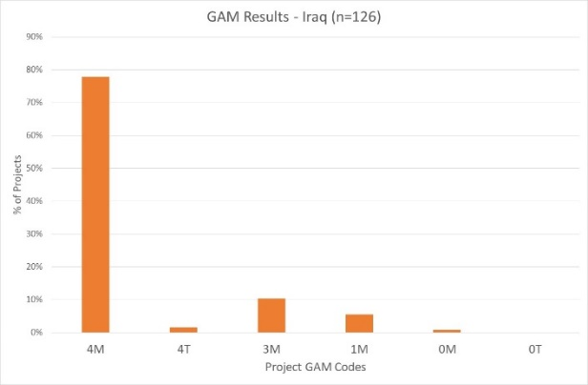
Of the 126 Iraq projects completing the GAM, 80% (100 projects) plan to respond to both gender and age differences (Code 4), including two which are targeted actions (“T”) with the specific purpose to reduce inequality. 13 projects (10%) intend to address gender (but not age) differences. There are also thirteen projects that do not mainstream gender and/or age.

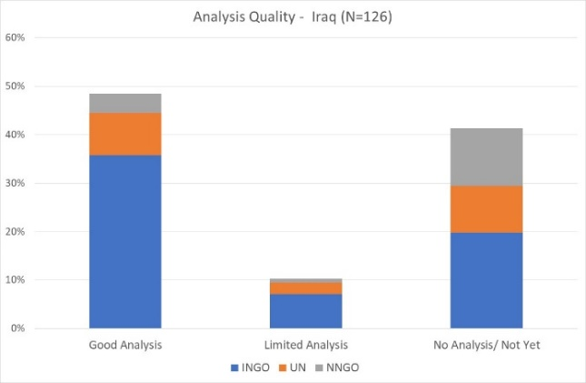
A very cursory scan of GAM submissions suggests Iraq projects have a higher than average understanding of gender-related issues in their context, compared to other humanitarian settings. Almost 50% of projects are able to ariculate and give examples of gender differences that affect how assistance is delivered. This is determined by Column Y of the Iraq GAM data, where project holders are asked to describe their gender analysis. Based on rapid review, projects that clearly describe or provide an example of role and/or power differences (“gender analysis”) are coded green. Only 10% of Iraq projects have a limited (yellow - 11 projects) or no gender analysis (red-52, 41%.)
These projects most often describe their policy or program, a commitment to address inequality rather than explanation of actual differences in the context. This reflects a common misunderstanding of tool: its purpose is not to persuade others of the value of a project, but rather an opportunity for project holders to articulate and confirm the relevance and coherence of their program actions. Projects lacking gender analysis may need support to understand how the marginalization of certain groups will impact on delivery of their services.
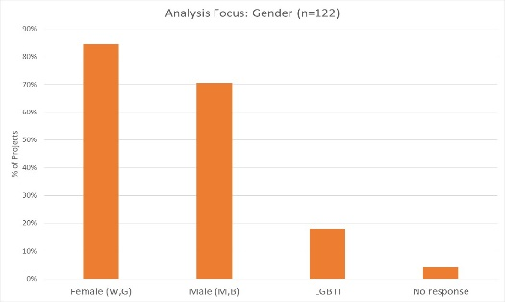
13% of projects say their analysis is concerned with all three gender groups; 57% of projects consider both females and males. Separately, 84% of projects consider females, and 70% males. 22 projects (18%) indicate their analysis is concerned with people of diverse gender sexual orientation/ gender identity (LGBTI).
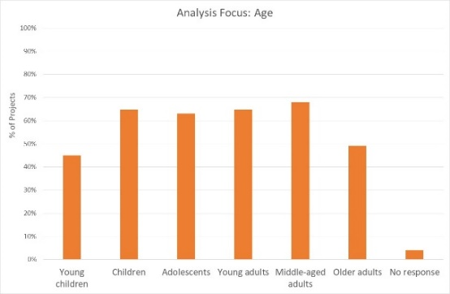
29% (35 projects) indicate their analysis is concerned with all age groups; others are more selective. Middle-aged, young adults and children are a priority 68% and 65% of projects, followed by adolescents at 63%. Older adults and young children are a focus of analysis in only 49% and 45% of projects respectively. It should be noted however, that issues affecting the prioritized gender and age groups are not always reflected in the analysis.
Support may be needed to help project holders understand how and gender and age analysis can inform the activities to be delivered, how different groups can be engaged, or how results will be measured. OCHA and cluster management can be involved to ensure project teams share a common analysis of who is at risk and why, and that they understand the implications of this for their project activities.
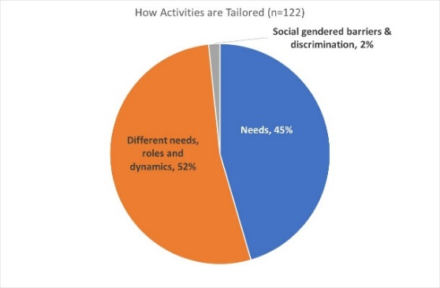
Slightly more projects plan to tailor activities according to the different needs, roles and dynamics of different groups, compared to those that consider only needs. Two projects constitute a “targeted actions” (Code T) with activities designed to reduce gender barriers or discrimination; these are normally a very small proportion of projects in humanitarian settings.

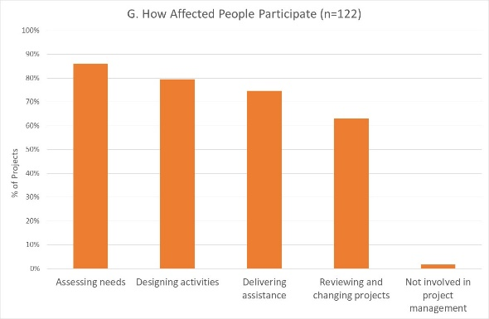
Iraq appears to be planning higher levels of engagement with affected people than many countries: 48% of projects say affected people will influence all stages of project management. 86% and 80% of projects intend to involve beneficiaries in needs assessment and activities design. The lowest level of intended participation is in project review and revision, where 63% of projects intend participation. There are only 2 projects where affected people will not be involved in any of these activities.
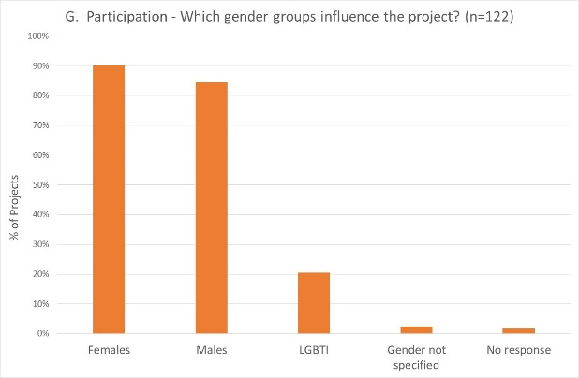
Females are expected to influence management in 90% of projects, and males slightly less. 20% of projects indicate that people of diverse gender/sexual orientation (LGBTI) will be involved; seven projects indicate that only LGBTI people will be involved. This is consistent with project narratives, where several projects describe barriers faced by this group.

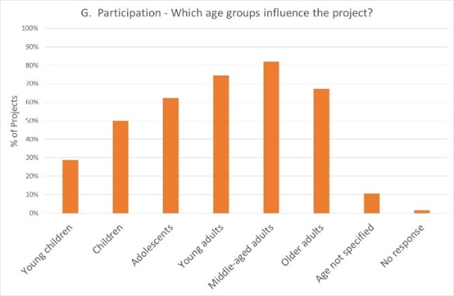
Over 70% of projects expect participation of middle-aged and young adults, followed closely by older adults. 62% of projects intend for adolescents to participate. 50% or less of projects will be engaged with children.

Reporting relative benefits
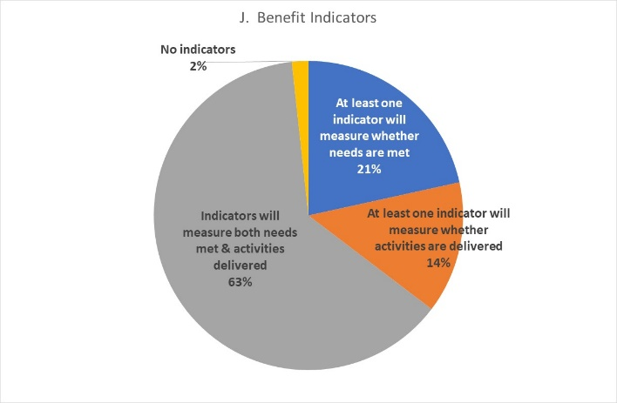
Of the 119 projects using the GAM for project design, 63% say they will be able to provide disaggregated information on both the activities delivered, and the needs met. A further 21% will report on needs met, with only 16 projects (14%) planning to report on activities delivered. Over 80% of projects will provide results disaggregated by sex, and around 50% will disaggregate results for one or more age groups.

Project Monitoring
Only three Iraq projects in the 2019 FTS have used the GAM for monitoring. This is too small a group for analysis so, with the exception of Project Benefits (GEM J), monitoring responses have been included in the above information.

Conclusion
There are several indications that Iraq projects have completed the GAM conscientiously as intended. The narrative descriptions are clear and consistent with the data provided; OCHA colleagues and numerous GAM resource people deserve much credit for this.
It will be important that all Iraq FTS projects (including the 49 that did not apply the GAM in project design) apply the GAM for monitoring. This can be done at any time during implementation, and will provide an important overview of accountability and inclusion in the Iraq response.

25 March 2020

