GAM Results:
Niger

Overview
There are 156 accepted projects in the Niger 2020 HPC; 15 of these (10%) have completed the IASC Gender with Age Marker. The IASC target for 2020 is that 80% of projects will complete the GAM. One organization completed one GAM for two projects, leaving 14 HPC projects Four projects made transcription errors when entering their GAM codes into HPC, either ‘upgrading’ the code received and/or changing the project focus from “M” to “T,” suggesting a misperception that the GAM code is a factor in project selection or funding.
A total of 33 projects in Niger have completed the IASC Gender with Age Marker, including the 14 accepted in the HPC 2020. 31 have used it for project design, and 2 for project monitoring; there are no projects claiming gender is “not applicable.” These results cover all Niger GAM submissions to date: 12 projects submitted Nov 2018-Mar 2019, and 21 submitted Nov 2019 – Jan 2020.
The design phase of the GAM asks users to consider four essential programming actions that contribute towards gender and age inclusion: analysis, tailoring of activities, participation, and benefits. The monitoring phase asks users to report on these four, plus eight additional indicators.
Design & Monitoring | Monitoring Only
- Analysis | - Data Disaggregation | - Targeting
- Tailoring of Activities | E. Gender-based Violence | F. Coordination
G. Influence (Participation) | H. Feedback & Complaints | I. Communication (Transparency)
J. Benefits | K. Satisfaction | L. Project Problems

In this first year of use, it is important to continue to raise awareness of the purpose of the GAM.
The IASC Gender with Age Marker was designed in response to requests from the field for a tool that would help humanitarians understand HOW to do better gender equality programming. People knew they weren’t getting it right, but there was little practical advice on HOW projects could be improved.
The GAM can be described as a “learning by doing” tool, based on the premise that systematically thinking about and responding the questionnaire will result in more inclusive and responsive projects. It is the process of discussing and answering GAM questions about the twelve programming actions that creates better projects - not the results that are achieved. Ideally the GAM is used as a team planning or monitoring exercise.
Niger GAM information summarized here demonstrates considerable attention to gender- and age-related issues, as well as several questions for further reflection and discussion among project holders using the tool.
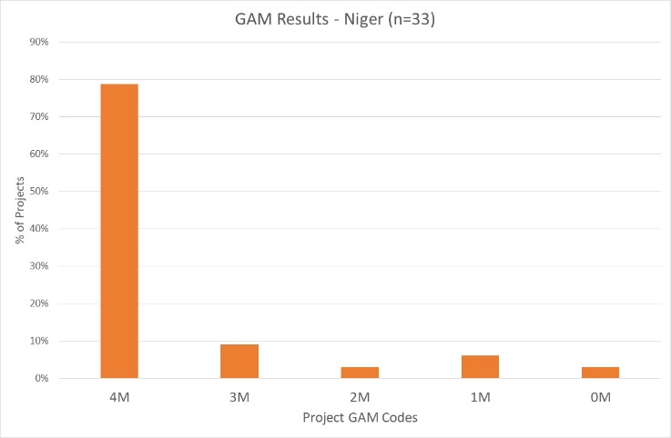
Of the 33 Niger projects applying the GAM, 79% (27 projects) plan to respond to both gender and age differences (Code 4), and 3 projects (9%) intend to address gender (but not age) differences. There are four projects that do not mainstream gender and/or age.

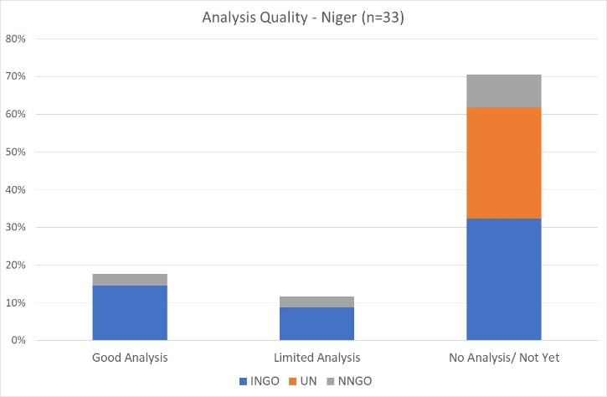
A very cursory scan of GAM submissions suggests less than 20% of Niger projects (6) demonstrate a good analysis of gender and/or age inequality in context. This is determined by Column X of the Niger GAM data, where project holders are asked to describe their gender analysis. Based on rapid review, projects that clearly describe or provide an example of role and/or power differences (“gender analysis”) are coded green. Four projects appear to have limited analysis (yellow - 12%.) Over 70% of Niger projects have no gender analysis/ not yet (red-24, 71%.) These projects most often describe an organizational policy or express an intention or commitment to address inequality, rather than an analysis of actual differences in the context. This reflects a common misunderstanding of tool: its purpose is not to persuade others of the value of a project, but rather an opportunity for project holders to articulate and confirm the relevance and coherence of their program actions. Projects lacking gender analysis may need support to understand how the marginalization of certain groups will impact on delivery of their services.

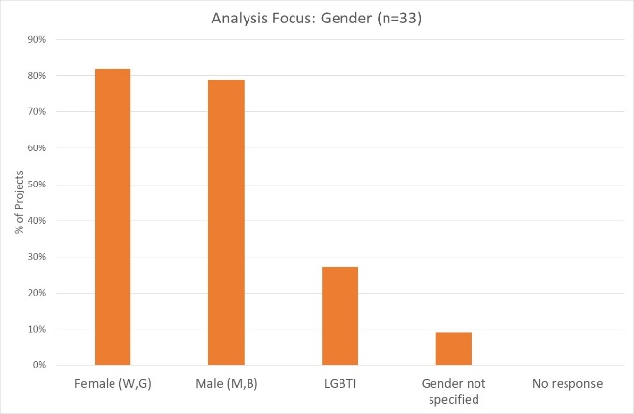
45% of projects say their analysis considers both females and males. Separately, 82% of projects consider females, and 79% males. 9 projects (27%) indicate their analysis is concerned with people of diverse gender sexual orientation/ gender identity (LGBTI). This may be a misunderstanding of terminology, as none of the project narratives refer to this group.

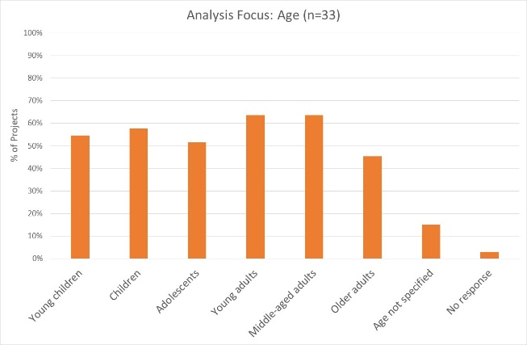
27% (9 projects) indicate their analysis is concerned with all age groups; others are more selective. 64% of projects are concerned with young and middle-aged adults, followed by children and young children. Adolescents and older adults are a focus of analysis in 52% and 45% of projects respectively. It should be noted however, that issues affecting the prioritized gender and age groups are not always reflected in the narratives.
Support may be needed to help project holders understand how and gender and age analysis can inform the activities to be delivered, how different groups can be engaged, or how results will be measured. OCHA and cluster management can be involved to ensure project teams share a common analysis of who is at risk and why, and that they understand the implications of this for their project activities.

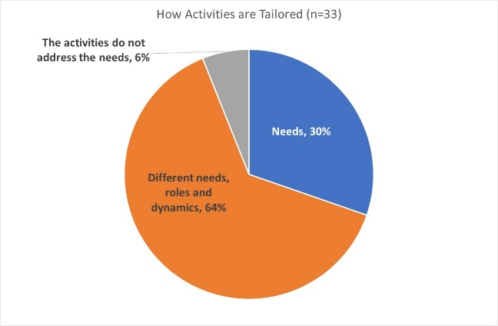
The majority of Niger projects (64%) intend to tailor their activities according to the different needs, roles and dynamics of different groups, while 30% adapt activities solely based on needs. Two projects acknowledge that their proposed activities do not address the needs (so may need some support with this.) There are no projects that constitute a “targeted action” (Code T) with activities designed to reduce gender barriers or discrimination; these are normally a very small proportion of projects in humanitarian settings.
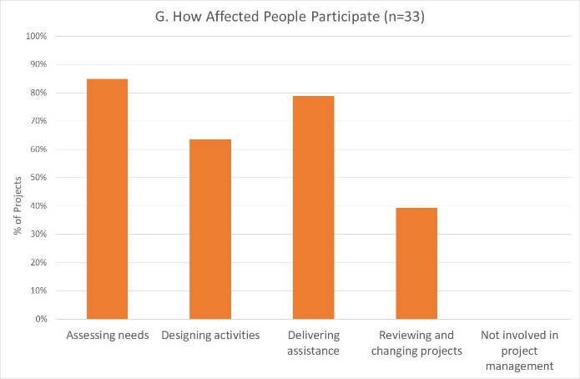
How affected people participate differs among projects. 24% of projects (8) say affected people will influence all stages of project management, and 24% have affected people involved in 3 out of the 4 areas, excluding project review and revision. Most projects will involve beneficiaries in needs assessment and in delivering the assistance. There are no projects where affected people will not be involved in any of these activities. It is interesting that the area where beneficiaries are expected to participate least is in reviewing and changing projects.
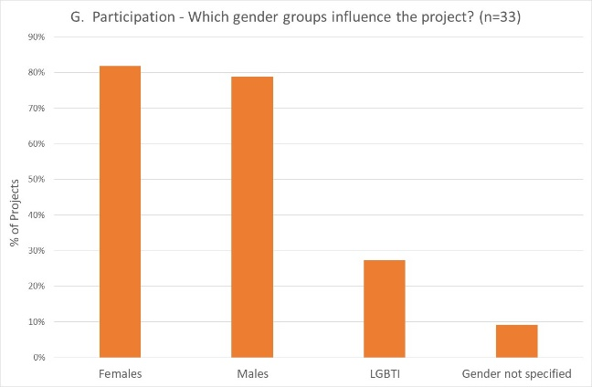
45% of projects expect both females and males to participate; 82% of projects will be influenced by females, and 79% by males. 9 projects (27%) indicate that people of diverse gender/sexual orientation (LGBTI) will be involved. Three projects (IOM, UNICEF,) indicate that only LGBTI people will be involved, suggesting possible misunderstanding of this gender category.

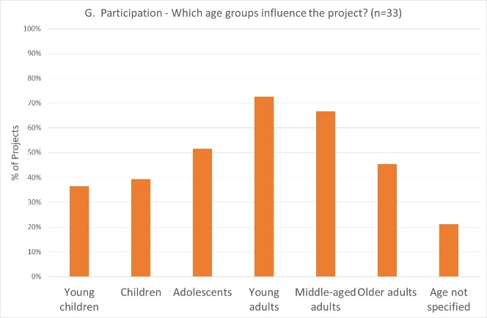
Participation by age groups reflects an overall trend seen in much larger sample sizes: while young children and children may be logically the least involved, the expected lower participation rates of adolescents and older adults may be a potential concern.

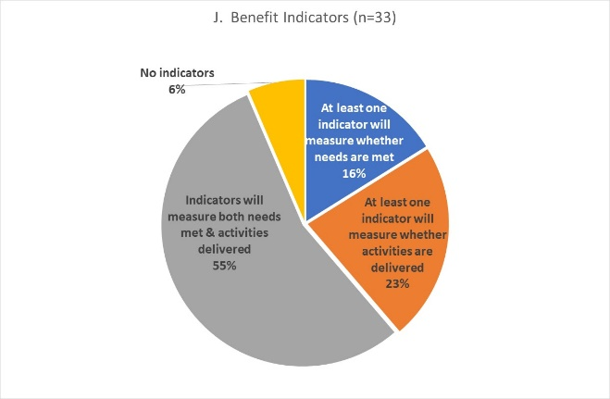
Reporting relative benefits
Of the 31 projects using the GAM for project design, 55% say they will be able to provide disaggregated information on both the activities delivered, and the needs met. Over 80% of projects will provide results disaggregated by sex, and more than 50% will disaggregate results for one or more age groups.

Project Monitoring
Only two Niger projects have used the GAM for monitoring, so do not provide a useful sample. However, responses still serve to demonstrate the future utility of the GAM, particularly its ability to describe accountability and protection in the monitoring phase, including for specific gender and age groups. A brief look at the monitoring results shows the type of information that will be available, and the importance of global reporting on these results.
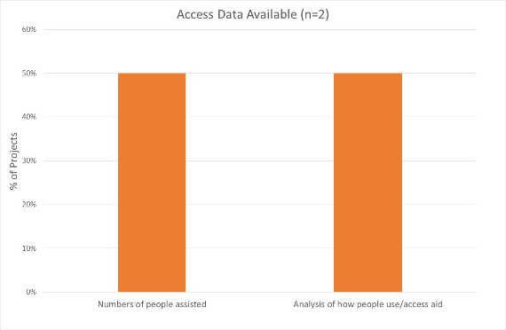
Access to Assistance: One of the two monitoring projects reports data on the actual numbers of people assisted, and one provides analysis of how people access or use the aid. One of the two projects indicate data is disaggregated by sex for one or more age groups.

Targeting: Both projects report that people access aid as planned, and that needs were met equally for all gender and age groups:
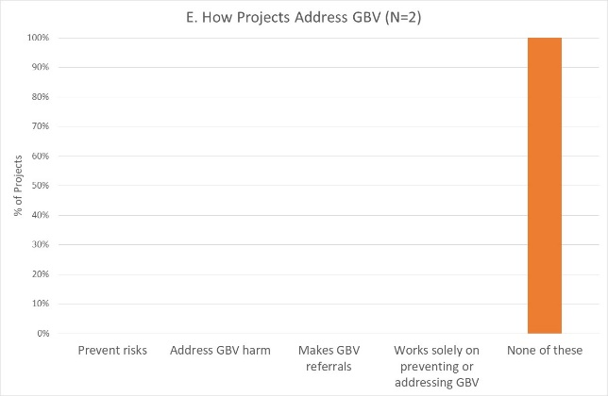
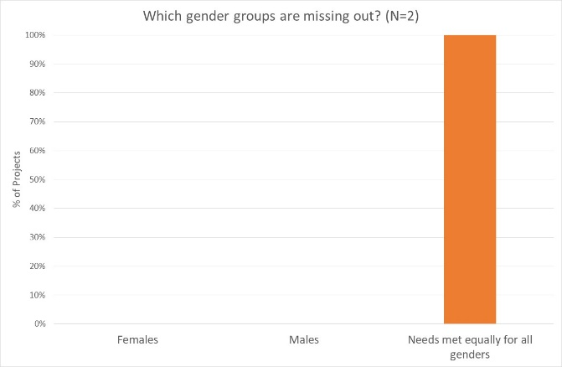
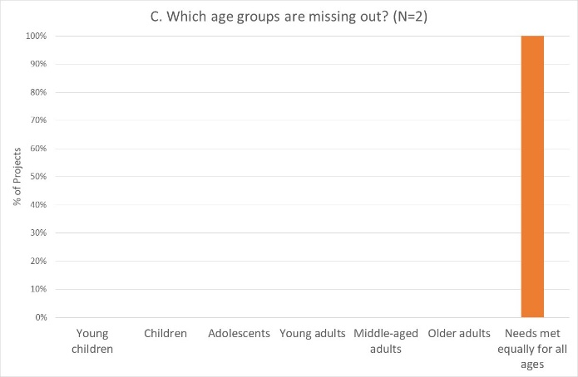

Gender-based violence: Neither of these two projects have any involvement with GBV prevention or response.

Coordination: Both projects indicate that monitoring information is shared in the cluster: one shares information disaggregated by sex and age, and one disaggregates by sex only.
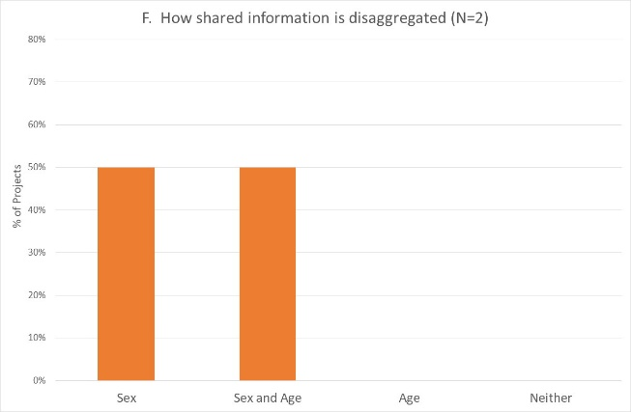
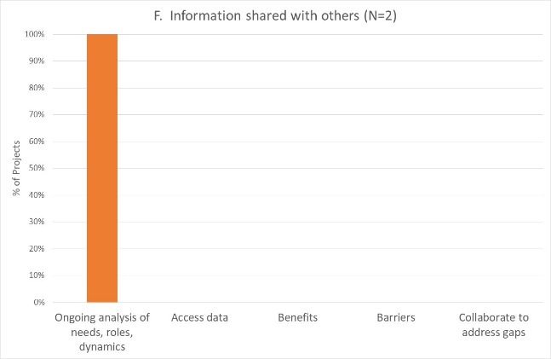

Complaints and Feedback mechanisms: Both projects say there is at least one way to make complaints, and one also reports that complaints result in changes. They report that procedures are the same for all gender and age groups.
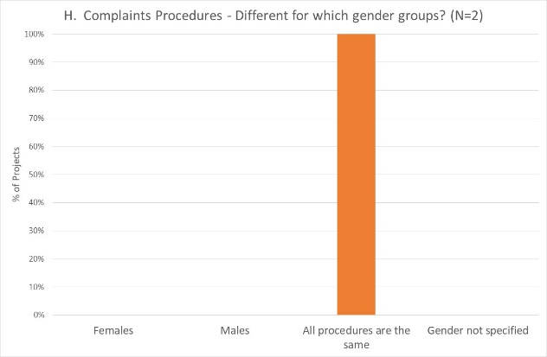
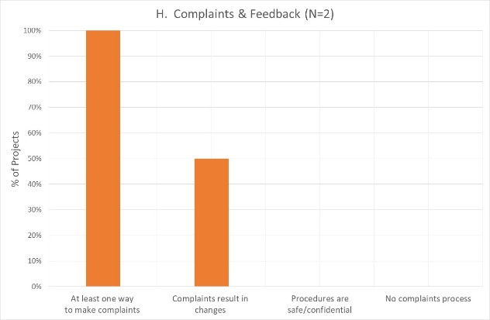

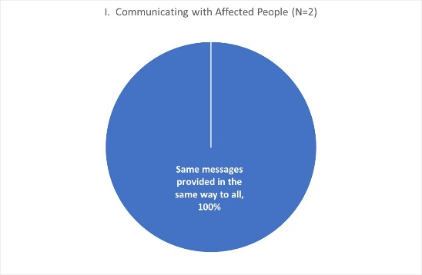
Communication with Communities/Transparency:
Both projects using the GAM for monitoring in Niger provide the same messages in the same way to everyone, so did not respond to questions on how communication is tailored for different gender or age groups.

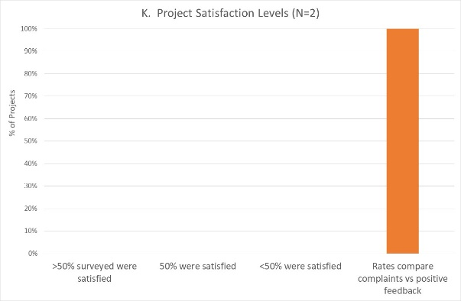
Satisfaction:
Neither project has a complaints and feedback mechanism, but estimate satisfaction levels based on complaints received, so did not respond to questions about satisfaction of different gender or age groups.

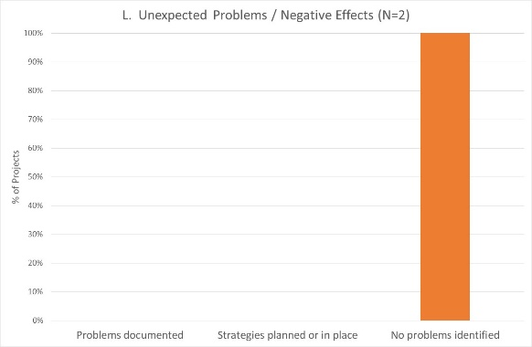
Dealing with negative effects: Both projects say no unexpected problems have been identified in monitoring, and consequently do not respond about which gender and/or age groups may have been more adversely affected.

Conclusion
The IASC Gender with Age Marker currently only looks at gender and age differences; the next version of the questionnaire will also address response for people with disabilities. The next version also recognizes that the questionnaire was too long (resulting in high levels of “no response,”) and will be considerably shorter.
While this overview of GAM use in Niger demonstrates its potential for supporting projects to provide relevant and responsive assistance for different groups, please view the data with caution. There is some evidence that the questionnaire is not always completed by an informed respondent. Response quality will improve with growing organizational and management interest in the results, and realization that attributable information is being reported globally.
Even this limited sample provides evidence and examples of what projects are doing well, where good programming capacity exists, and where support can be provided. An excellent starting point for gender advisors and focal points is Column X of the GAM database (Worksheet ‘Niger’), where organizations currently unable to articulate a simple gender analysis can be assisted to understand how this is fundamental to designing and implementing a gender-responsive project.

23 March 2020

